A review of recent advances in metaheuristic maximum power point tracking algorithms for solar photovoltaic systems under the partial-shading conditions
T. Sutikno, A. Pamungkas, G.Pau, A. Yudhana, M. Facta
Indonesian Journal of Science and Technology
Volume 7 Issue 1, April 2022, pp. 131-158
DOI: https://doi.org/10.17509/ijost.v7i1.45612

Bukti Korespondensi Email

Pengiriman artikel: 23 Maret 2022

Keputusan dengan revisi: 27 Maret 2022

Kirim Revisi: 2 April 2022

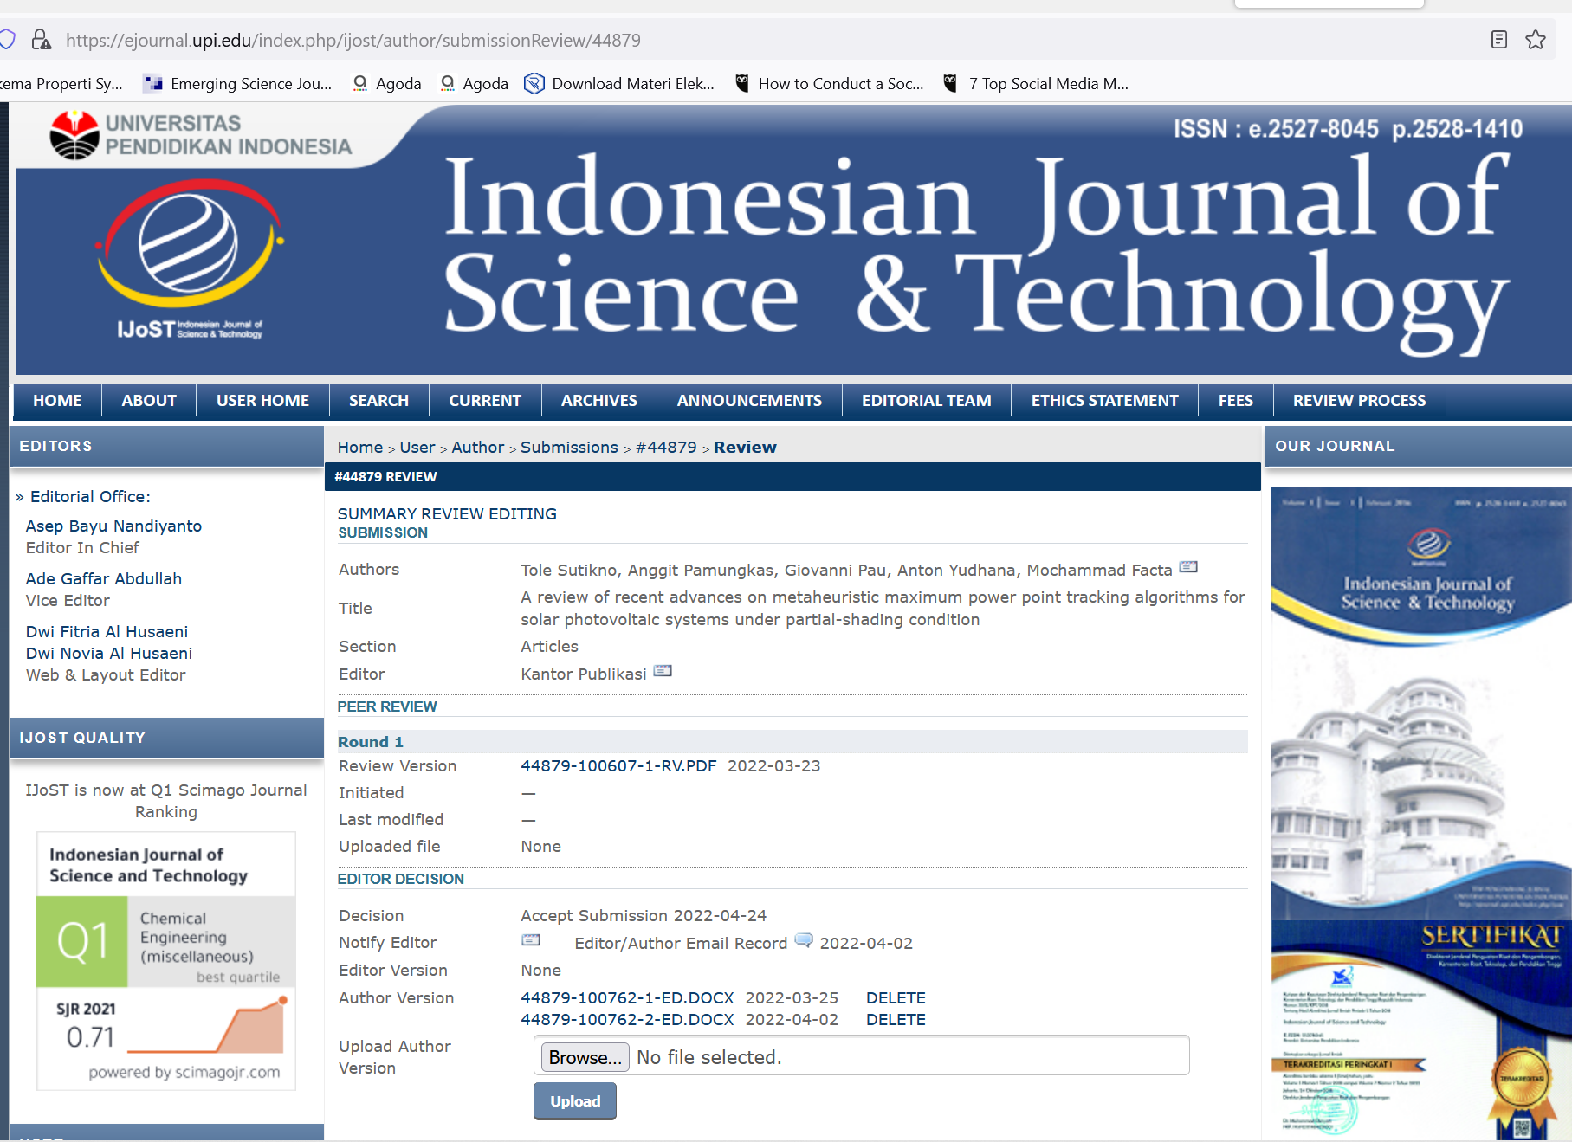

ACCEPTED: 24 April 2022

