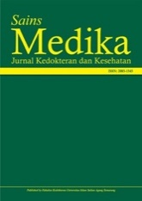

Sains Medika: Jurnal Kedokteran dan Kesehatan
journal homepage: http://jurnal.unissula.ac.id/index.php/sainsmedika/

CASE REPORT

Case Study: Disseminated Intravascular Coagulation at Autopsy of a Child with Severe Burns Resulting in Death

Muhammad Yusuf Arrozhi^{1*}, Rusyad Adi Suriyanto², Hendro Widagdo³

¹Department of Forensic Science and Medicolegal, Faculty of Medicine, Ahmad Dahlan University, Yogyakarta, Indonesia
^{2,3}Department of Forensic Science and Medicolegal, Faculty of Medicine, Gadjah Mada University, Yogyakarta, Indonesia
²Bioanthropology and Paleoanthropology Laboratory, Faculty of Medicine, Gadjah Mada University, Yogyakarta, Indonesia
Corresponding author, email: muhammad.arrozhi@med.uad.ac.id

ARTICLE INFO ABSTRACT

Keywords:
disseminated intravascular coagulation
forensic autopsy
burns in corpses

Childhood is a time of growth and development, both intellectually and emotionally. The Indonesian Child Protection Commission has observed a growing number of cases of violence against children, including physical and verbal abuse, which require special attention and handling. Physical violence can include burns, which are particularly dangerous in developing countries, where the mortality rate is high. Severe burns can result in inhalation injury and sepsis, which can cause coagulation disorders, making it easier for Disseminated Intravascular Coagulation (DIC) to occur. This study aims to describe the coagulation function of severely burnt patients, investigate the potential causes of DIC, and examine other clinical data. The study used a case study approach, analyzing the corpse of a child who suffered from severe burns. An autopsy was performed and supporting examinations were conducted to determine the cause of death. The examination of the patient's laboratory results, treatment records, corpse, and anatomical pathology revealed the presence of DIC. The autopsy of the child's corpse showed severe burns, pale coloring in the tissues under the nails, and blood clots in the epidural, left ventricle, right ventricle, and veins. The cause of death was determined to be severe burns causing multiple organ dysfunction.

Introduction
Childhood is a crucial period for physical, intellectual, and emotional growth and development. Monitoring by the Data and Information Center of the National Commission for Children has revealed that 62% of child violence occurs in close proximity to the child. Violence is a deliberate act that leads to physical harm or psychological trauma. One of the causes of verbal violence toward children is the lack of awareness among parents about such violence. The Indonesian Commission on Child Protection (KPAI) has reported a rising trend in child abuse cases in Indonesia, with 6.006 cases reported in April 2015. This number has steadily increased each year, with 171 cases in 2010, 2,179 in 2011, 3,512 in 2012, 4,311 in 2013, and 5,066 in 2014 (Setiawan, 2015).
Burns is a significant problem in developing countries, with over 2 million cases reported annually in India alone. The mortality rate from burns is higher in developing countries compared to developed countries, for instance, in Nepal, there are approximately 1,700 deaths per year for every 20 million people, which results in a mortality rate 17 times higher than in the UK. The high mortality rate can be attributed to various factors, including sepsis, inhalation trauma, and multi-organ failure (Hettiaratchy & Dziewulski, 2004).
Patients who experience severe trauma and burns often consume large amounts of coagulation factors and other regulatory proteins. However, severe burns can result in imbalances in the coagulation, fibrinolytic, and inflammatory systems. Inhalation injury and sepsis worsen the recovery prognosis and increase the risk of respiratory failure, septic shock, and DIC (Disseminated Intravascular Coagulation). Research on coagulation in severe burns remains limited (Zhang, Ba, Li, et al., 2022).
Therefore, the purpose of this study is to describe the coagulation function in patients with severe burns, to investigate the potential causes of its occurrence, and to gather other relevant clinical data.

Case Report
Obtained chronology, a child was subjected to violence in his home. According to the report, the child's father scolded him for an error and then poured gasoline on the child's body and set him on fire. The father attempted to save the child by embracing him, causing himself to also sustain burns. The mother discovered the incident and sought help from the neighbors to take both the victim and the father to the hospital.
The examination of the victim, while he was still alive, revealed vital signs with low blood pressure (100/60 mmHg), normal heart rate (98 beats per minute), increased respiration rate (28 breaths per minute), decreased oxygen saturation (88%), and increased body temperature (38ºC). The victim had 2A-degree burns all over his body and was receiving medical treatment, including an infusion, urinary catheter, and oxygen mask (Figure 1). The laboratory examination showed increased leukocytes (52.13x10³/µL), increased erythrocytes (6.23 x10⁶/µL), increased hemoglobin 18.1 g/dL, increased hematocrit 55.1%, increased platelet 808 x10³/µL, increased alanine transaminase 104 U/L, increased creatinine 1.56 mg/dL, increased random blood glucose 164 mg/dL and decreased albumin levels 2.70 g/dL.
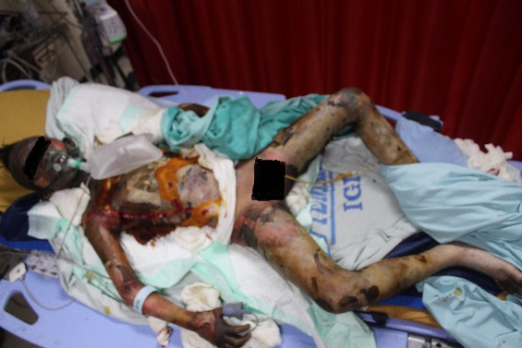
Figure 1. The patient when being treated in the Emergency Department of Dr. Sardjito Teaching Hospital

The autopsy of the victim revealed a body length of 140cm, a weight of 30.9 kg, and male sex with a total of 28 teeth. The whole body was found to have 2A-degree burns covering 94.5% of the body. There were also signs of escharotomy on the chest and abdomen, with pale tissue under the nails of the toes and hands and blood coming out of the right ear canal. An escharotomy was performed on the chest and abdomen of the deceased, as shown in Figure 2.

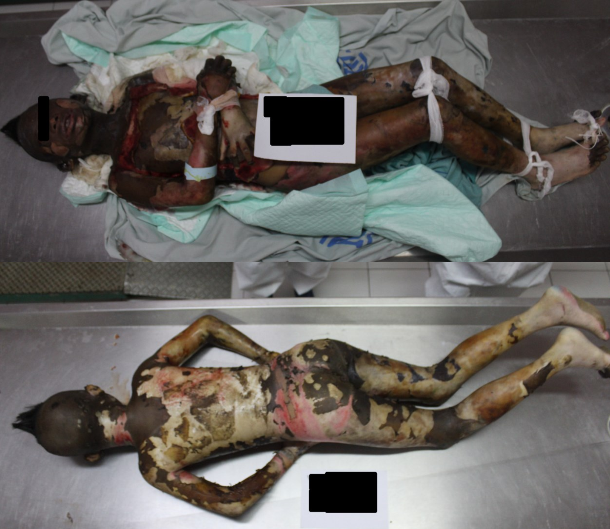
Figure 2. The corpse is seen from the front and back

The abnormalities found on internal examination of the deceased include there is no soot. There are blood clots under the brain's hard membrane (Figure 4), the veins of the heart, the left ventricle, the right ventricle (Figure 3), and the right abdomen (Figure 5).

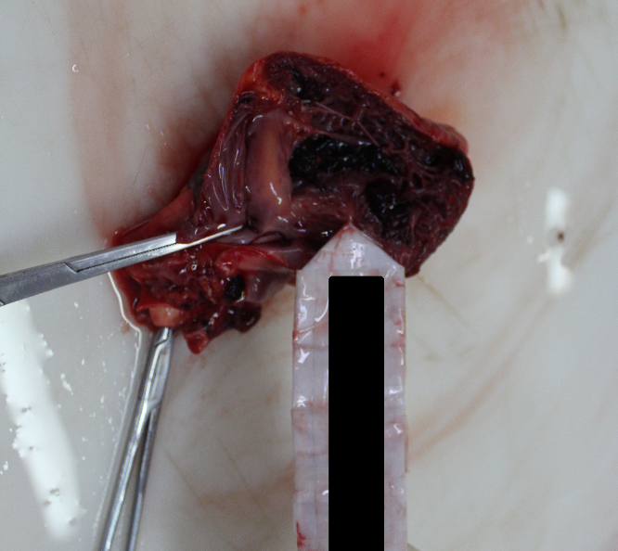
Figure 3. Blood clots in the left ventricle, right ventricle, and venous vessels

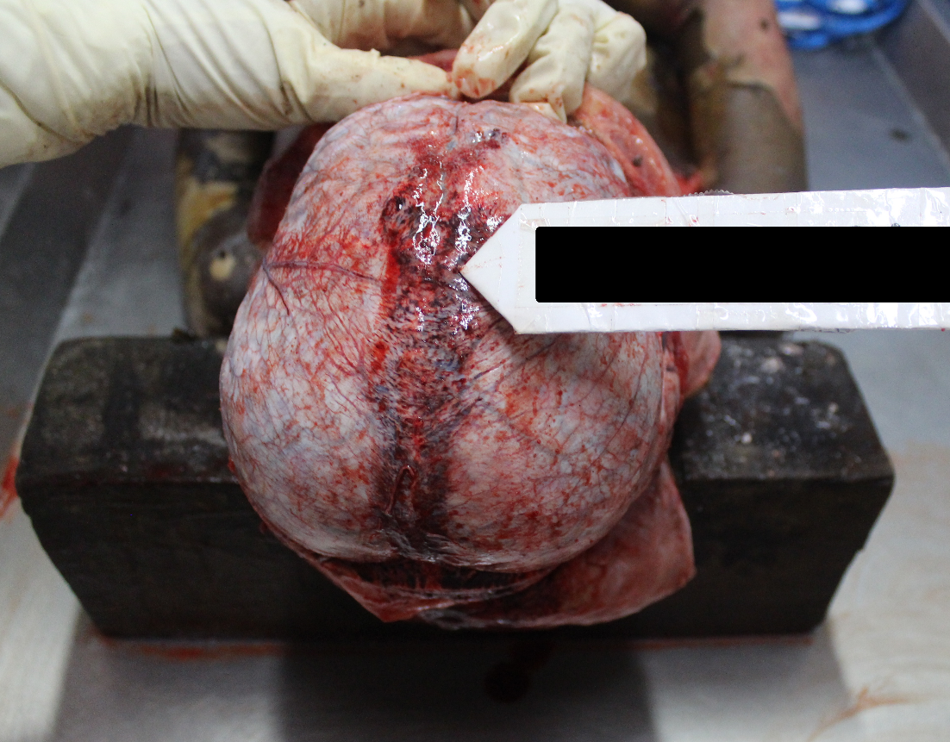
Figure 4. Blood clot in the brain's dura mater

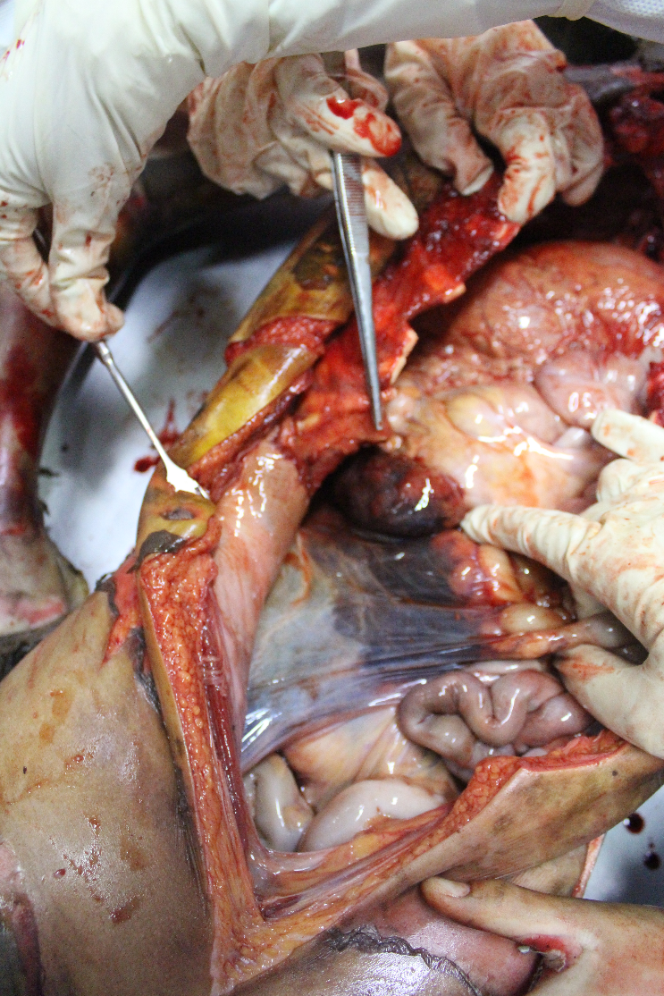
Figure 5. Blood clot in the right abdomen.

Upon examination of the anatomical pathology, the results obtained were in the form of:
- Brain : within normal limits
- Cerebral membranes : swollen with extensive extravasation of red blood cells (Figure 6).

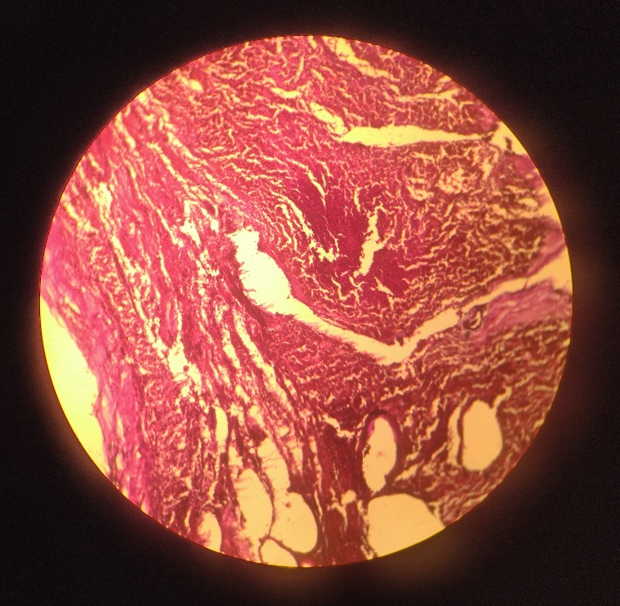
Figure 6. Dura mater with 10x microscope magnification

- Trachea : within normal limits
- Throat : within normal limits
- Heart : blood clots were found in the right and left chambers of the heart (Figure 7).

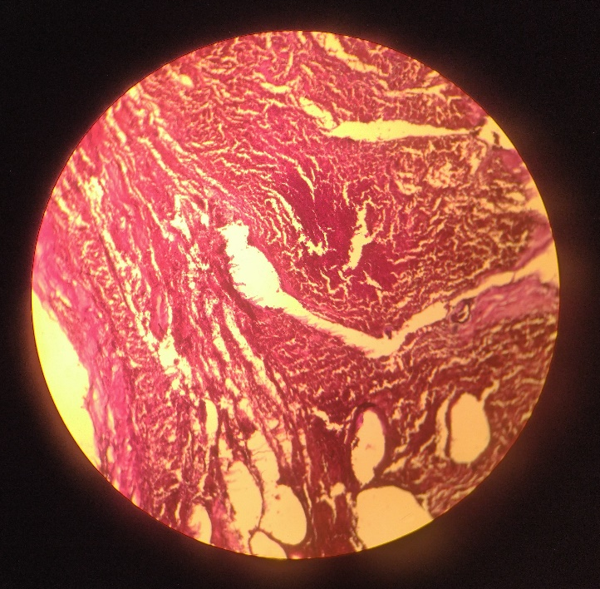
Figure 7. Right ventricle with 40x microscope magnification

- Lungs : swollen with dilation of blood vessels, and extravasation of red blood cells.
- Kidney : found extensive erythrocyte extravasation in fatty tissue at the edge of the right kidney, right and left kidney tissue normal (Figure 8).

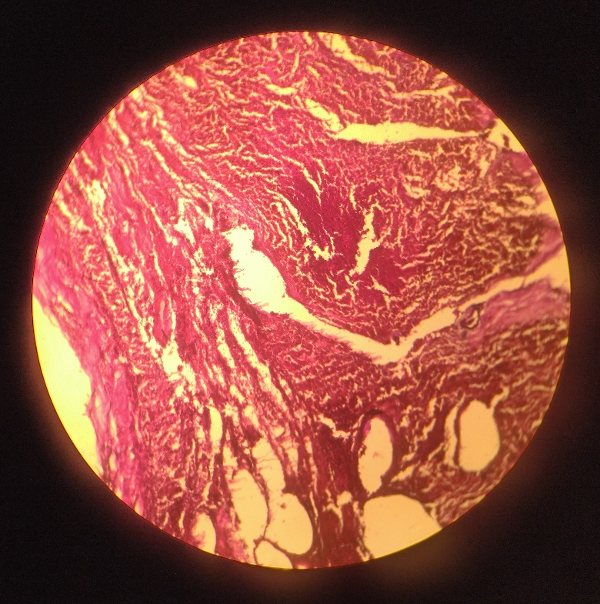
Figure 8. Right kidney with 10x microscope magnification.

- Liver : within normal limits (Figure 9).

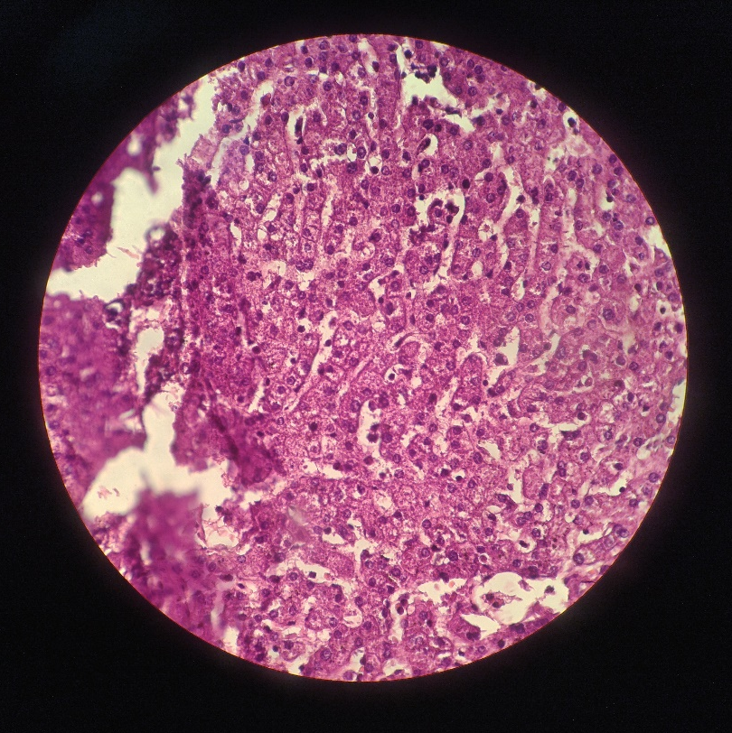
Figure 9. Liver with 40x microscope magnification

- Skin : 2A-degree burns (superficial partial-thickness burn), characterized by partial erosion of the epidermis, partially detached from the dermis to form subepidermal bullae. The upper dermis was swollen with extravasation of erythrocytes, necrosis, and neutrophil discharge (Figure 10).

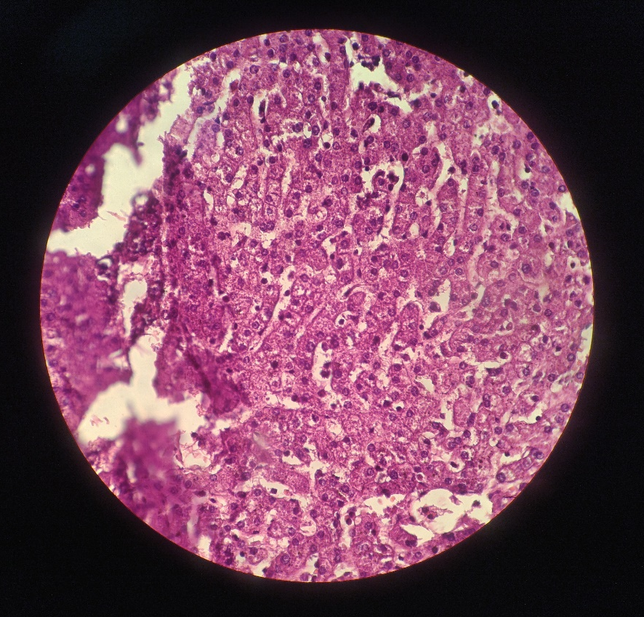
Figure 10. 2A-degree burn on the skin

Materials and Methods
According to Woodside (2017), there are several types of case study methods described, including single-method, single-source studies such as in-depth interviews, or one-group thematic non-perception tests. However, case study research is generally considered an expansive method with a layered approach. With equal emphasis placed on both qualitative and quantitative information, case study research results in a rich, data-driven story that is validated through a multi-source verification process. In this study, which focuses on a child who experienced severe burns, the case was analyzed starting from the examination performed while the child was being treated in the emergency room, the results of laboratory examinations, and finally the results of an autopsy and supporting examinations to determine the cause of death.

Results
  - Burns
Burns are classified as physical trauma resulting from high temperatures, which is the most common cause of heat sources to the body, including fire, hot surfaces, hot metals, hot liquids, and hot gases. Burns are a type of injury (tissue damage or tissue loss) caused by heat sources, high temperatures, electrical sources, chemicals, light, radiation, and friction. The severity of burns is classified according to the depth of the skin layer affected and is divided into degrees: 1-degree (superficial wounds), 2A-degree (partial thickness), 2B-degree (full thickness), and 3-degree (full thickness +) (DiMaio & Kimberley, 2021).
After a 3rd-degree burn, three concentric zones of tissue trauma can be observed: coagulation (areas in direct contact with the heat source appear white or charcoal), stasis (tissue perfusion appears), and hyperemia. Death from burns can occur immediately or later on. Causes of death include carbon monoxide (CO) poisoning, smoke inhalation, mechanical trauma, anoxia, and hypoxia (DiMaio & Kimberley, 2021).

  - Disseminated Intravascular Coagulation (DIC)
According to the International Society of Thrombosis and Haemostasis (ISTH) Scientific and Standardization Committee, Disseminated Intravascular Coagulation (DIC) is a syndrome characterized by activation of the intravascular coagulation process, leading to a loss of its normal localization. This activation can damage the microvasculature, potentially resulting in severe organ dysfunction. The intravascular activation of the coagulation process leads to the formation of thrombin and fibrin, causing small- to medium-sized vessel thrombosis, organ dysfunction, and severe bleeding. DIC can be associated with severe trauma and serious injuries (Taylor Jr., Toh, Hooth W. Keith, et al., 2001).
  - DIC Pathophysiology
According to Mitra, Wasiak, Cameron, et al., (2013) retrospectively found hypercoagulability within 24 hours after a burn, while Wiegele, Schaden, Koch, et al., (2019) reported that patients developed chronic hypercoagulability two weeks after a burn injury using a coagulation test at four-time points. When the pulmonary epithelium and alveolar macrophages are damaged by inhalation injury, tissue factor is released, activating the exogenous coagulation pathways and resulting in pulmonary coagulopathy. Hypoxia caused by inhalation injury can lead to local thrombosis, and sepsis can activate severe burns, which can in turn activate endogenous coagulation pathways and even result in DIC (Figure 11). Despite the increased risk of death, the close association between inhalation injury, burn sepsis, and coagulation in patients can exacerbate coagulation dysfunction after severe burns. Thus, additional studies are needed to better understand the association between inhalation injury, burn sepsis, and coagulation.
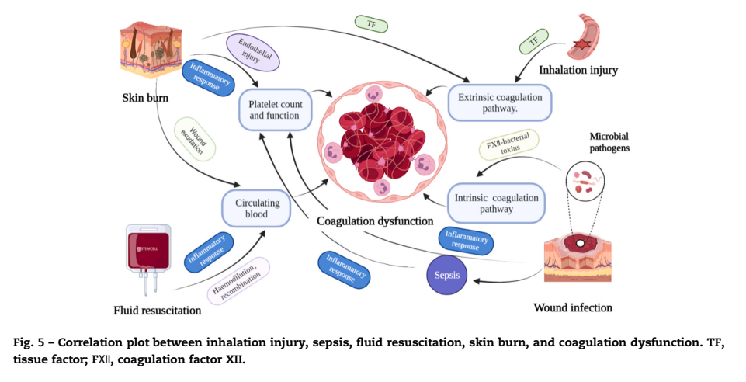
Figure 11. Correlation between inhalation injury, sepsis, fluid resuscitation, burn injury, and coagulation dysfunction. (Tissue factor) TF; (Coagulation factor XII) FXII (Zhang, Ba, Li, et al., 2022).

  - DIC Clinical Manifestations in Burn Patients
Some of the clinical manifestations observed in burn patients with DIC include thrombophlebitis that occurs at unusual sites, respiratory distress syndrome, kidney dysfunction characterized by a decrease in kidney function, central nervous system disorders such as loss of consciousness and seizures, dermal infarction and skin necrosis, as well as gray discoloration of the fingertips, toes, or earlobes (Thachil, 2016).
  - Scoring system
The recommendations used include guidelines issued by ISTH-SSC (International Society on Thrombosis Haemostasis-Scientific and Standardization Committee), the Japanese Ministry of Health, Labor, and Welfare (JMHLW), and the Japanese Association of Acute Medicine (JAAM) (Table 1) (Takemitsu, Wada, Hatada, et al., 2011).

  - Overt DIC
Defined as a condition where the vascular endothelium, blood, and its components have lost their ability to compensate and restore homeostasis in response to injury, resulting in multiorgan dysfunction due to thrombosis and/or bleeding. A score of 5 or more on the DIC assessment scale constitutes overt DIC (Table 2) (Taylor Jr., Toh, Hooth W. Keith, et al., 2001).
  - Non-overt DIC
It is defined as a condition of clinical vascular injury resulting in a severe burden on the homeostatic system, which temporarily prevents further inflammatory and hemostatic activation. The scoring systems used for the diagnosis of non-overt DIC include general coagulation tests, such as Prothrombin time and Fibrin Degradation Products, and more specific but not widely available tests that indicate intravascular thrombin production, such as Thrombin-Antithrombin (TAT) complexes, and the consumption of coagulation inhibitors, such as Antithrombin (AT) and Protein C (PC) (Wada, Thachil, di Nisio, et al., 2013).

Table 1. Diagnostic criteria for DIC (Takemitsu, Wada, Hatada, et al., 2011)
Establish | Points | JMHW | ISTH | JAAM
Underlying disease | 1 | 1 point | necessary | necessary
Clinical symptoms | 1  1 | bleeding*  organ failure | - | SIRS 1 point
Platelet counts (x10³/µl) | 1  2  3 | >80 but <120*  >50 but <80*  <50* | >50 but <100  <50 | >80 but <120 #1  80< #2
Fibrin-related marker | 1  2  3 | FDP (µg/mL)  >10 but <20  >20 but <40  >40 | FDP, SF, or D-dimer  Moderately increased  Markedly increased | >10 but <25  >25
Fibrinogen (g/l) | 1  2 | >1 but <1.5  <1 | <1 | -
PT, PT ratio,  Prolongation of PT | 1  2 | >1.25 but <1.67  >1.67 | Prolongation of PT  >3 but 6< | >1.2
Diagnostic of DIC | points | >7 | >5 | >4
*: 0 points with hematopoietic malignancy.
#1: or a 30% reduction in the platelet count.
#2: or a 50% reduction in the platelet count.

Table 2. Diagnostic Scoring System for Overt DIC (Taylor Jr., Toh, Hooth W. Keith, et al., 2001)
Variable | Overt DIC by ISTH | Overt DIC by KSTH | Points
Platelet count (/µL) | 50,000-100,000  <50,000 | <100,000 | 1 point  2 point
PT/aPTT | Prolongation of PT 3-6  Prolongation of PT >6 | Prolongation of PT >3sec or Prolongation of aPTT >5sec | 1 point  2 point
Fibrinogen (mg/dL) | <100 | <150 mg/dL | 1 point
D-dimer (µg/mL) | 0.5-1  1-3  >3 | Increase | 1 point  2 point  3 point
Total | Overt DIC > 5 points | Overt DIC > 3 points
ISTH: International Society on Thrombosis Haemostasis
KSTH: Korean Society on Thrombosis and Haemostasis
PT: prothrombin time
aPTT: activated partial thromboplastin time

Discussion
The Temanggung Police received a report from the public at approximately 2:00 p.m. concerning the burning of a child, allegedly committed by his biological father. Upon visiting the crime scene, witnesses were interviewed and evidence was collected, leading to the identification of the perpetrator.
In the laboratory examination of the victim, there was insufficient data to calculate the DIC score. However, the leukocyte count indicated that the victim was in septic shock, which is a significant factor in the development of DIC. The initial examination of the body revealed evidence of medical intervention in the form of escharotomy or fasciotomy, which was performed to prevent respiratory distress and relieve pressure on critical structures in the extremities (such as blood vessels and nerves). This escharotomy was performed without any signs of a full-thickness burn that would have caused edema and compromised blood vessels (Zhang, Labib & Hughes, 2022).
The examination also showed bruising and stiffness of the body, which were difficult to assess, and there was no decomposition. This was due to a "pugilistic posture," a condition where the muscles have coagulated due to heat, causing the contraction of flexor muscle fibers (Saukko & Knight, 2016). The external examination revealed burns to almost the entire body. The 12-year-old male victim had sustained 2A-degree burns, covering 94.5% of his body, as determined using the Rules of Nines and the Wallace formula for calculating total body surface area (Moore, Waheed & Burns, 2022).
The burns were characterized as superficial partial-thickness burns, with partial erosion of the epidermis and detachment from the dermis, forming subepidermal bullae. The upper dermis was swollen and showed signs of extravasation of erythrocytes, necrosis, and neutrophil accumulation (DiMaio & Kimberley, 2021). Examination of the nails revealed that all the fingers and toes were pale, a sign of decreased blood perfusion to the tissues. This was due to the severe burns causing DIC and leading to blood clots and impaired perfusion (Thachil, 2016).
The mechanism of death resulting from a 94.5% 2A-degree burn that causes blood clotting can be explained as follows: The victim sustained high-temperature trauma antemortem, evidenced by the presence of erythema from capillary distention, vesicles containing serous fluid that showed albumin, chloride, PMN (polymorphonuclear) cells, and a reddened, inflamed base with raised papillae. The skin around the vesicles was bright red or copper, a characteristic that distinguishes between postmortem and antemortem burns. Although no soot was found in the throat or respiratory tract during the autopsy, which is a sign of antemortem burning, the other findings indicate that the victim died as a result of the burns (Saukko & Knight, 2016).
This case of burning a 12-year-old Mongolian male is rare and presents a challenge for physicians and forensic pathologists in determining the cause of death. The examination of burn victims often focuses on inhalation and skin trauma, but it is important to consider the potential for increased blood coagulation and the development of DIC. A complete forensic investigation, including laboratory and anatomical pathology, can help reconstruct the case and establish the cause of death. This case provides valuable references for similar cases in the future.
It is recommended that standard operating procedures be established for the examination of burn victims and fluid or human tissue samples to ensure that the most appropriate therapeutic doses can be determined and more cases can be saved in the future.

Conclusions
The male body, with a body length of one hundred and forty centimeters, weighs thirty-nine kilograms. There are second-degree burns covering ninety-four point five percent of the body. There are blood clots under the brain's hard membrane, in the veins of the heart, the left ventricle, the right ventricle, and the right abdomen. The cause of death was due to severe burns, resulting in multiple organ dysfunction. The time of death cannot be estimated due to the extensive nature of the burns.

Acknowledgment
Conflict of Interest: The authors have declared that there is no conflict of interest.
Thank-you Note: We would like to thank all the lecturers and colleagues at the Department of Forensic Medicine and Medicolegal at Universitas Gadjah Mada and the Faculty of Medicine at Universitas Ahmad Dahlan for their guidance and support in publishing this review.
Funding: This review was conducted at no cost.
Data and Material Availability Section: The data sets collected and presented in this review are available as open-access data as cited in our references.
Author Contributions: MYA, RAS, and HW directed the discussion, collected all the data, and prepared the script. All authors participated in writing and approved the final manuscript.
Competitive Interests: The authors have stated that there is no competing interest.
Publishing Permit: Not required.
Ethics Approval and Participating Consent: Not required.

References
DiMaio, V.J.M. & Molina, K.D. (2021). DiMaio’s forensic pathology. (3rd edition). New York, CRC Press. doi:10.4324/9780429318764.
Hettiaratchy, S. & Dziewulski, P. (2004). ABC of burns introduction. BMJ. Vol: 328. Page: 1366–1368. Available from: www.firekills.gov.uk. doi: 10.1136/bmj.328.7452.1366. PMID: 15178618.
Mitra, B., Wasiak, J., Cameron, P.A., O’Reilly, G., et al. (2013). Early coagulopathy of major burns. Injury. Vol: 44 (1). doi:10.1016/j.injury.2012.05.010.
Moore, R.A., Waheed, A. & Burns, B. (2022). Rule of nines. Available from: https://www.ncbi.nlm.nih.gov/books/NBK513287/?report=printable. PMID: 30020659
Saukko, P. & Knight, B. (2016). Forensic Pathology 4th ed. (4th edition). New York, CRC Press. ISBN: 13:978-1-4441-6508-1
Setiawan, D. (2015). KPAI: Pelaku Kekerasan Terhadap Anak Tiap Tahun Meningkat. Komisi Perlindungan Anak Indonesia. Available from: https://www.kpai.go.id/publikasi/kpai-pelaku-kekerasan-terhadap-anak-tiap-tahun-meningkat.
Takemitsu, T., Wada, H., Hatada, T., Ohmori, Y., et al. (2011). Prospective evaluation of three different diagnostic criteria for disseminated intravascular coagulation. Thrombosis and Haemostasis. Vol: 105 (1). doi:10.1160/TH10-05-0293.
Taylor Jr., F.B., Toh, C.-H., Hooth W. Keith, Wada, H., et al. (2001). Scientific and standardization committee communications: towards a definition, clinical and laboratory criteria, and a scoring system for disseminated intravascular coagulation. ISTH Website. PMID: 11816725
Thachil, J. (2016). Disseminated intravascular coagulation: a practical approach. Anesthesiology. Vol: 125 (1). doi:10.1097/ALN.0000000000001123.
Wada, H., Thachil, J., di Nisio, M., Kurosawa, S., et al. (2013). Harmonized guidance for disseminated intravascular coagulation from the international society on thrombosis and hemostasis and the current status of anticoagulant therapy in japan: a rebuttal. Journal of International Society on Thrombosis and Haemostasis. Vol: 11 (11), page: 2078–2079. doi:10.1111/jth.12366.
Wiegele, M., Schaden, E., Koch, S., Bauer, D., et al. (2019). Thrombin generation in patients with severe thermal injury. Burns. Vol: 45 (1). doi:10.1016/j.burns.2018.09.020.
Woodside, A.G. (2017). Case study research: core skill sets in using 15 genres. Emerald Group Publishing Limited. ISSN: 0289-6001.
Zhang, L., Labib, A.M. & Hughes, P.G. (2022). Escharotomy. Available from: https://www.ncbi.nlm.nih.gov/books/NBK482120/?report=printable. PMID: 29489153.
Zhang, T. Ning, Ba, T., Li, F., Chen, Q., et al. (2022). Coagulation dysfunction of severe burn patients: a potential cause of death. Elsevier-Burns Journal. doi:10.1016/j.burns.2022.05.003.

- Explain the prevalence of DIC in Children with burnt trauma in introduction paragraph one
- The writing structure is a literature review first, then a case report
- It is necessary to add the length of time of treatment until the victim dies
- There is no need to add a discussion of materials and methods because this journal is designed as a Case Report--OK
- It is necessary to describe the existing DIC score, to establish the diagnosis of DIC as a result of death
- There are not enough data to determine DIC
- Need to add suggestions in the same case

