BEYONCE’S SOCIAL CRITICISM TOWARDS VIOLENCE ON BLACK PEOPLE AS SEEN IN BEYONCE’S ALBUM “LEMONADE”

An Scientific Publications
Submitted as a Partial Fulfillment of the Requirements to Obtain
Sarjana Sastra Degree English Literature Department in
Faculty of Literature, Culture, and Communication
Universitas Ahmad Dahlan

BY
ZAKIANIS
1500026066

ENGLISH LITERATURE DEPARTMENT
FACULTY LITERATURE, CULTURE, AND COMMUNICATION
UNIVERSITAS AHMAD DAHLAN YOGYAKARTA
2019

BEYONCE’S SOCIAL CRITICISM TOWARDS VIOLENCE ON BLACK PEOPLE AS SEEN IN BEYONCE’S ALBUM “LEMONADE”
By
Zakianis
1500026066

ABSTRACT
This research is entitled Beyonce's Social Criticism Towards Violence On Black People As Seen In Beyonce’s Album “Lemonade”. This study has two research objectives: the first is the description of social criticism for Black people, and the second is Beyonce's social criticism dealing with violence against Black people as seen on the album "Lemonade".
The researcher uses descriptive qualitative method by hearing the music several times from the album as the main data of this study. The secondary data are from books, journals, articles, theses, and internet to support this research. The researcher applies the data that have been obtained by using three theories, the theory of social critics and the theory of racism along with theory of popular culture to analyze the social criticism Beyonce in the album "Lemonade".
As a result of this study, the researcher concludes that Beyonce seeks to sensitize and motivate Black people not to be discouraged by what they are experiencing at the moment. Through his songs and video clips Beyonce strongly criticized the polices brutality in America against Black people who were always considered wrong. Beyonce also hopes that later polices, brutality can be reduced or even no longer exists. The name of the Beyonce album "Lemonade" teaches that from a lemon that is very acidic, when processed, it will become fresh lemonade and is very desirable for everyone.

Keywords: Social Criticism, Black People, Violence

BEYONCE’S SOCIAL CRITICISM TOWARDS VIOLENCE ON BLACK PEOPLE AS SEEN IN BEYONCE’S ALBUM “LEMONADE”
Oleh
Zakianis
1500026066

INTISARI
Penelitian ini berjudul Kritik Sosial Beyonce Terhadap Kekerasan Pada Orang Kulit Hitam Seperti Yang Terlihat Dalam Album Beyonce “Lemonade” Peneliti menggunakan lagu-lagu dan video klip dari album music Beyonce, karena dia menceritakan kritik sosialnya tentang diskriminasi, rasisme, dan kekerasan yang masih dialami oleh Orang kulit hitam di Amerika. Penelitian ini memiliki dua obyektif penelitian: pertama dekripsi kritik sosial untuk orang kulit hitam, dan kedua kritik sosial Beyonce berhadapan dengan kekerasan terhadap orang kulit hitam seperti yang terlihat di dalam album “Lemonade”.
Peneliti menggunakan metode deskriptif kualitatif dengan mendengarkan music beberapa kali dari album sebagai data utama penelitian ini. Kemudian didukung dengan data yang diperoleh dari buku, jurnal, artikel, skripsi, dan sumber elektronik. Peneliti mengaplikasikan data yang sudah diperoleh dengan menggunakan tiga teori, teori kritik sosial dan teori rasisme bersama dengan teori budaya populer untuk menganalisis kritik sosial Beyonce di album "Lemonade".
Hasil dari penelitian ini, peneliti menyimpulkan bahwa Beyonce berusaha untuk menyadarkan dan memotivasi orang-orang kulit hitam untuk tidak berkecil hati dengan apa yang mereka alami saat ini. Lewat lagu-lagu dan video klipnya Beyonce sangat mengkritik tentang kebrutalan polisi di Amerika terhadap orang kulit hitam yang selalu dianggap salah. Beyonce juga berharap bahwa nantinya kebrutalan polisi dapat berkurang atau bahkan sudah tidak ada lagi. Nama dari album Beyonce “Lemonade” ini mengajarkan bahwa dari sebuah lemon yang sangat asam nantinya jika diolah akan menjadi limun yang segar dan sangat diinginkan setiap orang.
Kata kunci: Kritik Sosial, Orang Kulit Hitam, Kekerasan

CHAPTER 1
INTRODUCTION

- Background For Choosing The Subject
Music in the United States is a reflection of a multi-tribe population with a variety of musical styles. The United States has the largest music market and it stread out over the world. Since the beginning of the 20th century, some the U.S. pop music, has been heard and followed globally. In the present, many musicians who use video clips to promote the results of there work. The video clip is also a lot of its own deep meaning. It is like the issue of American Black violences.
Then there is still a lot of violence committed by White people against Black people. Many Black Americans say four things as fields of discrimination, namely the treatment of police officers, jobs, courts and schools. So here Beyoncé opposed the existence of this by making an album entitled "Lemonade" in the album, there were several songs whose lyrics had deep meaning about black people.

- Scope of the Study
The study is about research of the social critics in Beyoncé album Lemonade. Morever, it also highlights on Beyoncé's social critics towards violence on Black people.

- Problem Formulation
- What are with violences on Black people in the album “Lemonade”?
- How are Beyoncé's social criticisms dealing with the violences toward Black people as seen in the album “Lemonade”?

- Review on the Related Studies
In this section the researcher aims to avoid plagiarism, and to prove that this undergraduate paper has been never taken by anyone. First, the researcher made an observation on google, hence she finds the undergraduate paper which discusses on social critic that is “Social Criticsm of Bob Dylan’s Song Lyrics: A Sociological Study of Literature” by. Hafid Muhadi (A 320 090 160) the English Education Department of Universitas Muhammadiyah Surakarta. Again, she finds the undergraduate paper by Kezia Windra TP, the International Relations of Gadjah Mada University. She focuses on the movement of black people in Jamaica independence until the early 1970s. Researcher focused on how is Rastafaria and reggae can be seen as a form of resistance against black people the dominance of white people in Jamaica in the post-independence years. Undergraduate paper by Arif Rahman Hakim (1400026102) English Letters Department student of Universitas Ahmad Dahlan. He focuses on the discrimination against American white rappers a reflected in Curtis Hanson’s film 8 mile Then, the researcher takes online sources observation to look for the topic correlated with political matters, thus some articles reveal social critics matters.
- Theoretical Approach
In this study, the research is under American Studies supported by an interdisciplinary approach from Henry Nash Smith.
“The best thing we can do is to conceive American Studies as collaboration among men working from within existing academic disciplines but attempting to widen boundaries impasse by conventional methods of inquiry…” (1) (Smith 1980 : 14)

This research takes two disciplines both social and culture. In sociology aspect it takes account on critical social theory by Paul Ricoeur. He states
“Critical social theory often speaks the language of mainstream social and political thought supplemented by a conceptual vocabulary necessary to address changing conditions and new forms of injustice and oppression"
Besides a sociological approach, the researcher also adopts some theories in cultural issues. They are theory of racism and theory of popular culture. Popular culture theory is applied in this study because this research refers to an album, and in the album there are several songs whose lyrics contains very deep messages.
Pop culture is a culture which have characteristic as vulgar and it is famous just for a while. Pop culture includes artifact such as food, sport, mass, media, fashion, song, and lyrics, situational comedy and comic strips. Some characteristic of popular culture are to give pleasure and entertainment. (Storey, 1993 : 3)
Moreover, racism is to be a by problem in America. Some cases about racism still exist, mainly verbal and acts. Willey states that,
“Racism is systematic, with structured inequalities that support a schema, replete with polices, practices, norms and tradition, that automatically disadvantage and exploit one social group for the good of another group.”

- Method of Study
This research is under a descriptively qualitative research. The method is a procedure, the way or ways of doing things. The method is an important role in the writing of research. It gave many contributions to researchers in using the data types the authors should take. This method is also used to manage data systematically design research. This work that is qualitative, data collection and pass it on to the descriptive. Then researcher later in this paper uses several methods to conduct research that includes research method, method of collecting data, and method of analyzing data
CHAPTER II
THEORETICAL FRAMEWORK

In this study, theory is one important part because it is used to examine data to get good results. Especially in American studies, it is called an interdisciplinary approach. Therefore, researchers can analyze problems from various sides and perspectives
- Social Criticism in America
Criticism is not only about good taste, but must also involve ways of analyzing and form special experiences that are usually not possessed by others. (Eagleton, 2003: 70). According to Curtis, criticism is an analysis and evaluation of something that aims to increase understanding improve work and broaden appreciation. (Curtis, 1996: 284)
Song lyrics are the result of an author's interpretation in viewing a phenomenon that happened at that time. This phenomenon is not only understood as an understanding of the sociology of the people, but something more abstract; for example in terms of psychological aspects and ideas of thought, even dynamism the definitive meaning of music from time to time can be used as a reference for works next literature. Song lyrics that can be said to be good are always relative; cohesive between the author's observational object and the reader's taste in interpreting the work. (Ricoeur 2006: 14).
- A brief description of “Lemonade” album
The album Beyoncé is titled "Lemonade". This album is the sixth solo album by American recording artist Beyoncé which was released on April 23, 2016. Before Lemonade was present, Beyoncé released the single "Formation" on February 2016. The bounce genre song was sung at the 50th Halftime Superbowl.

B.1. Anger
Other songs that were quite attention-grabbing were songs that were Hold Up, where Beyoncé had a scene singing in a reggae rhythm while slamming a baseball bat into a car glass. Interestingly, the baseball bat printed a logo that read 'hot sauce' which immediately reminded us of the typical lyric fragments on his last single, Formation.

B.2. Equality
Beyoncé again raised feminism issue and gender equality in a song known as 6 Inch. The equality demanded by Beyoncé is about the status of the star she carries and how is the status can be utilized to empower other women to achieve their existence.
As in the lyrics of the song titled "Formation" in it mentions the call to Black women to make formations in order to protect themselves from discrimination by White people. The following are excerpts from the lyrics to the song "Formation" in the album Lemonade.
B.3. Depression
Together with James Blake musician, Beyoncé sang a song called “Forward” for 1 minute 20 seconds. This song is the shortest song on the album Lemonade. In addition to Black people, Beyoncé also composed songs for herself about her love problems with her own husband who was reportedly having an affair. The song "Forward" is a song that illustrates how Beyoncé is very depressed when he found out her husband was having an affair.

B.4. Movement of non-white groups
As if continuing to raise the issue of equality of rights for non-white groups in the United States, Beyoncé again presented a song that was stomping and flaming. The song is titled Freedom and sung by a rapper who is also equally critical on this issue, namely Kendrick Lamar. <http://www.esquire.co.id>

- Black People in American Multiculturalism
The United States has long been regarded as one of the superpowers in the world based on its economic and political strength. Known as the center of innovation and business, this has become a key driver behind its cultural and economic growth. The country is located in the central part of North America, which is the location of forty-eight neighboring states, along with the capital district of Washington, DC. The United States is flanked by the Pacific and Atlantic Oceans in the west and east, bordering Canada to the north, and Mexico to the south.
American culture is considered to be the most individualistic culture in the world. The concept of the "American Dream", or the notion that social life in America is better, develops among many people and plays an important role in attracting immigrants. Although mainstream culture states that the United States is a country with a classless society, experts find that there are significant social class differences in the country, these differences appear in terms of socialization, language use, and values.
Middle-class and professional Americans have pioneered and introduced contemporary social trends such as modern feminism, environmentalism, and multiculturalism. Self-image, social perspective, and expectations of American culture have been linked to the achievements and progress of the United States. While the habits of Americans who tend to judge something based on socio-economic achievements in general are considered as positive attributes. <http://www.globaloneworld.com>

C.1. Multiculturalism
The meaning of multiculturalism is the coexistence of different societies. Multiculturalism in the United States has a long quiet history. The United States, since its establishment, acknowledges workers from diverse social foundations, many of them, at the time, controversial. To begin with, Germans inquire questions around whether they can or will become "real Americans." Then questions arise almost the Chinese and after them Irish individuals and Eastern European migrants. Presently Hispanic-Americans and Muslim-Americans are inquired these questions. In some limited cases, exclusive policies have been overcome and bunches have gotten to be as American as the relatives of Mayflower passengers. With carefully thought out endeavors in reacting to the unused worldwide circumstance, there's no reason why modern ethnic and religious immigrant groups, and those who take after, cannot be effectively integrated into American life with those who gone before it. (Renshon & Stanly, 2011).

C.2. Racism
As a racial group, black people will form a special group in American society. They can demonstrate to the world almost their presence with an ideological perception that a group may have existed before in sociological reality, but they shape themselves by choice, they decide their possess categories, and groups are decided by shared culture and shared ancestry. (Glazer, 1970:59).
According to Webster's New World College Dictionary, racism is a conviction or doctrine that states racial contrasts in character, insights, etc. And the predominance of one race over another: bigot convention also, usually, looks for to preserve the purity that's assumed to be from a race. Or other race (Wiley, 1953).
It describes that racism still exist in America. There are some factors triggering racism. That can be stated follows:
C.2.1. Stereotype
Stereotypes are beliefs about individuals who put them into one category and don't permit for person varieties. This social believe is learned from others and kept up through rules in social interaction. (Franzoi, 2008: 199)
C.2.2. Prejudice
Prejudice is an attitude that cannot be justified or wrong (usually negative) towards an individual based only on the individual membership of a social group.
For example, a person can have a prejudiced view of certain race or gender, etc. (E.g. Gender). < https://www.simplypsychology.org/prejudice.html>

C.2.3. Discrimination
According to Storey, race is a cultural and historical category, a way of making a contrast implying between people of various skin colors (Storey, 2009: 167). In addition, race may be a group of people who are marginally different from other groups in a combination of acquired physical characteristics. , but race is additionally significantly determined by popular social definitions (Horton, 1964: 286). it can come from skin color or bloodlines. So, it may well be in the event that skin color got to be the space between people that led to the development of racism.

- American Popular Culture
American popular culture is one of the most popular approaches among other approaches. From American popular culture can be used to see various aspects such as film, advertising, literature, lifestyle, and also music. Because music is a very prominent aspect of this approach. Therefore researchers used this approach to examine Beyoncé's album entitled “Lemonade”. This definition of popular culture as Storey states in Cultural Theory and Popular Culture: An Introduction that the definition of popular culture often supported by claims that popular culture is mass-produced commercial culture, whereas high culture is the result of an individual act of creation. Therefore, it only deserves moral and aesthetic response. Whatever the method employed, those who wish to make a case for the division between high and popular culture generally insist that the division between the two is absolutely clear (Storey : 6).
Popular culture is the big phenomenon across the world and one of the most popular cultures is music. In this undergraduate thesis, the researcher explains why music becomes one of the most popular cultures in the world. Music has been popular since long time ago. Many people try to develop music by creating Songs every single year or even month to give what the consumers wants until its becomes popular. (John Storey: 17)

CHAPTER III
DISCUSSION

- Description of Social Criticism on Black People’s Violences In The Lemonade Album
Before explaining the description of social criticism for black violence, it would be nice if we first knew about social criticism, it can be seen in the last chapter about social criticism theory “Theory of social criticism in literary works is not only the relationship between wealth and poverty, but includes a variety of social problems in society. Social problems are also obstacles in the effort to achieve, these problems can be in the form of social and cultural problems, economic problems, politics, religion and race. (Damono, 1979: 25) In this section the researcher describes about social critics toward racism of violences which is divided into several important points.

- Prejudice
In this album Beyonce deliberately provides video footage related to violence against Black people in America. Because according to various data sources that researcher obtained, the violence experienced by Black people is the reason is still not strong.
According to Magazine Humboldt Kosmos, Jimmy Calanchini and his colleagues concluded that black people are at risk of being killed by police in areas with higher levels of racial prejudice than in other areas. because there are no official statistics that can be trusted about the violence in the police in America so they use data collected by the British daily The Guardian. Jimmy Calanchini and his colleagues concluded that black people are at risk of being killed by police in areas with higher levels of racial prejudice than in other areas. Because there are no official statistics that can be trusted about the violence in the police in America so they use data collected by the British daily The Guardian. The data recorded by the Guardian is the number of people from each ethnic group killed by police in each region.

In the lemonade album there is a song that describes this prejudice, the song is entitled Formation. This song has been performed by Beyoncé at Super Bowl 2016, Beyoncé performed with Cold Play, Bruno Mars, and Mark Ronson. In his appearance Beyoncé wearing costume similar to the Black Panthers costume, a black militant group who had made a concern in the US in 1966 to 1982. Beyoncé's appearance was considered racist by some American citizens, but there were also pros or support.

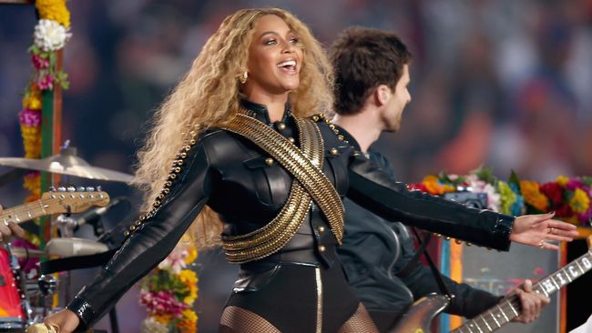
Pict 1. Beyoncé In Super Bowl 2016.

There are 2 guest artists who give oral interludes to this song, the first being Anthony Barre, who uses the name Messy Mya (he was shot dead in New Orleans in 2010). And then the second voice is Big Freedia, a New Orleans who specializes in Bounce Music. New Orleans's voice is related to videos that occur in the City. The clip video, directed by Melina Matsoukas, is a footage from a 2013 documentary about a bounce music scene in New Orleans called That B.E.A.T. and the scene of a police car going under water and riot police holding their hands up recall Hurricane Katrina and Black Lives Matter Movement.

- Stereotype
The stereotype of violence against African-Americans in the US is an ethnic stereotype that only concludes that African-American men are dangerous criminals. This stereotype is a fact that is still uncertain because the majority of African-Americans have never committed any crime and have never been armed. But many stereotypes that claim to bring African-Americans as criminals often appear in American popular culture.
The song from the Lemonade album which further illustrates the stereotype of violence on black people, which is entitled Freedom, is the tenth song from the Beyoncé 2016 album playlist, Lemonade. And is sung by Beyoncé and collaborates with Kendrick Lamar. Which is the song of struggle and the unique strength of African-American women. In the other words the song "Freedom" has the theme of women's empowerment specifically for African-Americans.
Eight blacks left, death is around the corner
Seven misleadin' statements by my persona
Six headlights wavin' in my direction
Come on
Five-O askin' me what's in my possession
Yeah, I keep runnin', jump in the aqua ducts

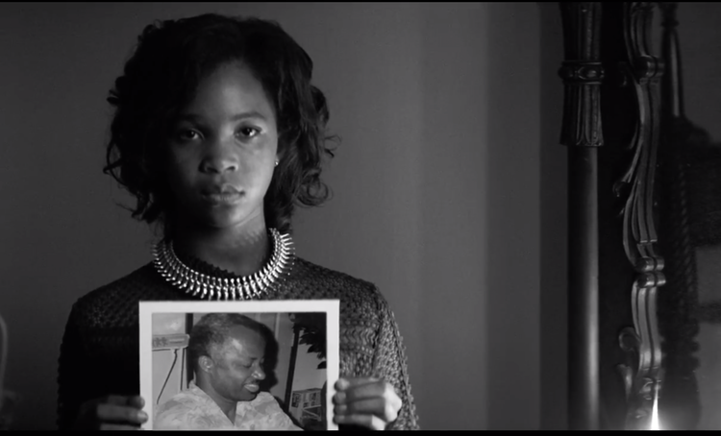
Pict 5.
The lyrics and pictures above explain that the suffering that has been experienced by black men has been so outrageous that many have been killed by American police for reasons that are not strong enough in a rule of law. Seen from the video clip footage the mothers of black men killed by police holding photos of their sons including Michael Brown and Eric Garner. They were shot by a white police officer.

- Racism
Racism, as explained in the previous discussion, racism in America is still very strong where black people there often get acts of violence by the local police. in this album "Lemonade" in the video clip almost entirely looks black people. The researcher assume that what Beyonce is doing is a criticism of racism that occurs, Beyonce wants to call that African-Americans are also the same citizens who should get the same treatment by the government and the police without discrimination and violence as it is today. The previous point the researcher had discussed was that the victims of the violence were almost entirely from innocent black people.
Black Lives Matter consisting of black activists is an organizational movement that once demanded a law on weapons. When Barack Obama only served as President, blacks and Hispanics had very high expectations and also hopes for the protection of rights and laws. But now many of them are disappointed in Obama because almost no meaningful action and change. Previously, too many had said when Obama took office that America had entered the "Post Racial" era, a country without racial differences and discrimination, but it was only a dream that never materialized.

Racism is very visible in the video clip, while the lyrics are more inclined towards social criticism from Beyonce.

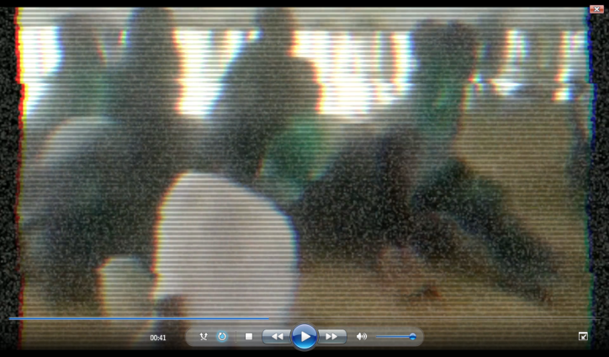
Pict 7.
In the lyrics "Best foot forward just in case, When we made our way to now, It’s time to listen, It’s time to fight" the lyrics are a compliment to themselves, represented by Beyonce and James Black that they have become the best in protecting themselves and others for the violence and discrimination they experience. In the next lyrics "Now we’re going to hold doors open for a while, Now we can be open for a while" the lyrics of the song are also expressions and wishes of the black people who are still oppressed they really want to be free like other citizens. Free in terms of politics, economics, religion, etc. Beyonce's social criticism conveyed in the lyrics of the songs and even the video clips reaps the pros and cons.

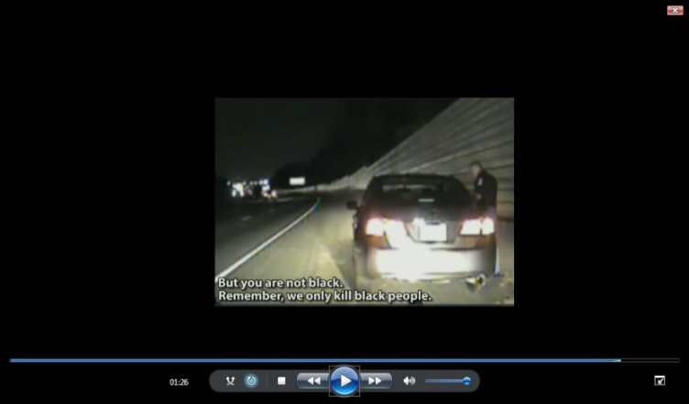
Pict 8.

In the last part of the video clip there is a video footage of a policeman stopping a car driver, and the policeman tells the car driver a sentence that is not properly said by the apparatus to civilians "But you are not Black. Remember, we only kill Black people". From the video it increasingly explains that the police brutality in America against Black people still occur, even they are not reluctant to take one's life about racial differences.

- Violences
According to International Justice Resource Center, the Inter-American Commission on Human Rights (IACHR) has examined the racial differences that are widespread in the American criminal justice system. Police violence against African-American descendants in America formed the most concise conclusion which contained "America has systematically failed to take preventative measures and to train its police forces to carry out their task in a rapid manner. This has led to frequent use of violence based on racial bias and prejudices that tend to result in murder for reasons that are not yet clear of African-Americans ".
Forms of violence here the researchers divide it into two parts namely verbal violence and non-verbal violence.

  - Verbal Violences
Verbal violence is "violence against feelings" mentioning harsh sentences without touching the physical but hurt someone's heart and feelings. Usually the sentence is threatening, frightening, insulting, and exaggerating the mistakes of others. Verbal violence experienced by Black people in America according to researchers tends to be less than non-verbal violence. an example of verbal violence is hate speech, the target of hatred occurred at Ivy League University, Pennsylvania, as many as 100 African-American students were ridiculed through social media groups as "Death Penalty". They were sent a lot of photos that show the past events of the ethics of black people were sentenced to death by hanging on a tree. From the example of that incident certainly there are still many more verbal violence experienced by black people.

  - Non-Verbal Violences
In America non-verbal violence experienced by black people is more common such as beatings, stopping cars on the road and then patting them to look for weapons, not only that the police are not even reluctant to shoot black people to death for reasons that make no sense. As experienced by Michael Brown and Eric Garner.
Black people and Hispanics, in particular, also worry about being stopped if they drive a good car in a simple or upscale community, drive a tattered car in a neighborhood that is mostly filled with white residents, or drive any type of car in an area have a high crime rate. This affects everyone, from ministers and professional athletes, to lawyers and super rich people.

- “Lemonade” Album As Popular Culture

In the last part the researcher explains about the album "Lemonade" as popular culture. Multicultural elements in America contribute greatly to the music industry, from pop, rock, jazz, to blues. The album "Lemonade" is Beyonce's sixth album, in this album there are discussions about race, violence, feminism, social media and the music industry. The pop music genre in this album has had a lot of influence in the era of globalization, as seen in the lyrics and clips of its clips that discuss race, discrimination, and violence against Black people. Simon Firth in Music and Identity argues that music construct our sense of identity through the direct experiences it offers of the body, time and sociability, experiences which enable us to place ourselves in imaginative cultural narratives (Firth 124).

CHAPTER IV
CONCLUSION

The conclusion of this research is the results of the discussion and analyzing the research objectives. In this undergraduate thesis, the researcher chooses Beyonce's album "Lemonade" to be the subject of this study for several reasons. First, the beyonce album "Lemonade" is an album created by Bey based on her love story with her husband Jay-Z, for alleged infidelity committed by Jay-Z. but that's not the only reason for Beyonce to create the album "Lemonade", another reason is that Beyonce wants African-Americans to not experience discrimination, racism, and violence anymore so that Beyonce created several songs on this "Lemonade" album whose lyrics contain Bey's social criticism. Second, because most of Beyonce's previous albums always had unique meanings and goals and many people liked Bey's works. Third, because the Beyonce’s album “Lemonade managed to break the record for best-selling album sales throughout 2016. The album "Lemonade" has been sale 2.5 million copies both in physical and digital form. As explained earlier, this undergraduate thesis focuses on discussing Beyoncé's social criticism towards violence on Black people as seen in Beyonce’s album Lemonade.
The first result is about the description of social criticism, The rise of violence against black people in America made many people criticize the action, because the violence was very wrong because the victims of the violence were mostly shot by local police on suspicion reasons, not to mention those black people are still being stereotyped that they are criminals especially black man. Most African Americans experience violence and discrimination in the political, economic, cultural, etc.
The second result is, as discussed previously, the researcher chose the Beyonce album "Lemonade" as the object of study. In this album there are 12 songs 3 of which contain Beyonce social criticism of the violence experienced by black people. The first song is "Formation" in the lyrics and the video clip illustrates very clearly that Beyonce invites black people to rise and fight. Then in the second song entitled "Freedom" this song is also not inferior to the song "Formation" still with social criticism Beyonce, the difference in this song Beyonce is not alone in conveying social criticism, he and Kendrick apply. The last song "Forward" is indeed not sung by Beyonce, but rather by James Black, in the video clip depicting black people who are mistreated by white people. And the name of the Beyonce album "Lemonade" teaches that from a lemon that is very acidic, when processed, it will become fresh lemonade and is very desirable for everyone.
So from a literary work can actually be a social critique of the creator, with the hope that those who are intended in the literary work understand and understand that discrimination, racism, even the violence they do is not a good thing. Because it will be very detrimental to those who become victims.

Works Cited

Abar, A. Z. (1999). Kritik Sosial, Pers dan Politik Indonesia dalam Kritik. Yogyakarta: UII Press.
Curtis, D. B. (1996). Komunikasi Bisnis Dan Profesional. Jakarta: Rosda Jayapura.
Damono, S. D. (1999). Sosiologi Sastra: Sebuah Pengantar Ringkas. Jakarta: Pusat Pembinaan dan Pengembangan Bahasa DepDikBud.
Firth, S. (2000). Music and Identity. New York.
Gilroy, P. (2003). Black Music Research Journal. Los Angeles.
Hakim, A. R. (2018). Discrimination Against American White Rappers As Reflected In Curtis Hanson Film 8 Mile. Yogyakarta: Universitas Ahmad Dahlan.
Horton, J. (2003). Liberalism and Multiculturalism: Once more unto the breach. In Haddock, and P. Sutch, B. (Eds). Multiculturalism, identity, and innovations in political theory. London and New rights: Routledge.
Imam Muhni, D. (2003). Method Of American Studies. Yogyakarta: Graduate Program Gadjah Mada University. American Studies.
Levin, H. (1983). Literature as An Institution. England: Penguin Book.
McDowell, T. (1984). American Studies. Minneapolis: University Of Minnesota Press.
Millet, J. (n.d.). http://www.culturalsavvy.com/understanding american_culture.htm 2013. Norwood, George. (2016).
Renshon, S. (2011). Multiculturalism In the U.S: Cultural Narcissism and The Politics Of Recognition. http://cis.org/renshon/politics-of-recognition.
Ricoeur, P. (2003). Ricoeur's Critical Theory. Albany, NY, United States: State University of New York Press.
Ricouer, P. (2006). Hereneutika Ilmu Sosial. Kreasi Wacana: Kreasi Wacana.
Smith, H. N. (2007). The American West as Symbol and Myth. Harvard University Pers.
Sons, J. W. (1953). Racism: Webster's New World College Dictionary Ohio. Wiley Publishing Inc.
Storey, J. (2006). "Cultural Theory and Popular Culture: An Introduction" 5th ed. University of Sunderland.
Storey, J. (2009). Cultural Theory and Popular Culture an Introduction: Fifth Edition. Person Education.
Walzer, M. (1987). Interpretation and Social Criticism. United States: Harvard University Press.
Wiley, J. (2010). White Privilige and Racism: Perceptions and Actions. Chicester, United Kingdom: Sons Ltd.
23 04 2019. 06 10 2019. <https://www.beyonce.com/album/lemonade-visual-album/songs/>.
n.d. 02 10 2019. <https://www.britannica.com/topic/racism>.
09 08 2018. 01 10 2019. <https://www.dw.com/id/diskriminasi-kulit-hitam-di-amerika-serikat/g-18091393>.
02 12 2017. 20 09 2019. <https://apabedanya.com/yang-beda-dari-album-terbaru-beyonce-lemonade/>.
03 04 2017. 02 10 2019. <http://www.esquire.co.id>.
02 03 2019. 06 10 2019. <http://www.koran-jakarta.com/beyonce-rilis--freedom---untuk-hari-perempuan-internasional/>.
02 11 2015. 06 10 2019. <http://www.koran-jakarta.com/beyonce-rilis--freedom---untuk-hari-perempuan-internasional/>.
09 04 2016. 06 10 2019. <https://media.iyaa.com/article/2016/04/lemonade-jadi-album-terbaik-beyonce-ini-alasannya-3440954.html>.
08 08 2009. 06 10 2019. <http://www.globaloneworld.com>.
5 6 2019. 6 10 2019. <https://www.simplypsychology.org/katz-braly.html>.
11 7 2018. 15 5 2019. <https://www.simplypsychology.org/prejudice.html>.

