BUKTI KORESPONDENSI ARTIKEL JURNAL BEREPUTASI

Judul | Employee Work Performance in State-Owned Enterprises in Indonesia: Is a Reflection
Nama Jurnal | International Journal of Innovative Research and Scientific Studies, vol. 5 No. 4, Pp. 363-377, ISSN : 2617-6548 Tahun 2022
Penulis | Endah Utami, Sigit Handoyo, RR Yockhisna Setio Negoro, Wirawan Hardinto

No | Perihal | Tanggal
1 | Proses Submisi | 24 Agustus 2022
2 | Penerimaan Submisi | 24 Agustus 2022
3 | Hasil review | 5 Oktober 2022
3 | Proses Revisi | 6 Oktober 2022
4 | Accepted | 22 September 2022
5 | Published | 31 Oktober 2022

PROSES SUBMISI
24 AGUSTUS 2022

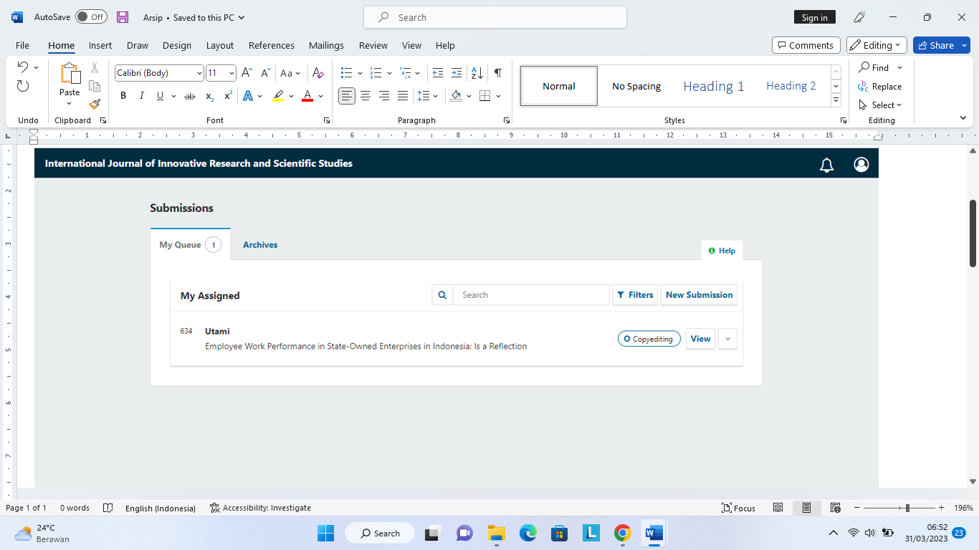

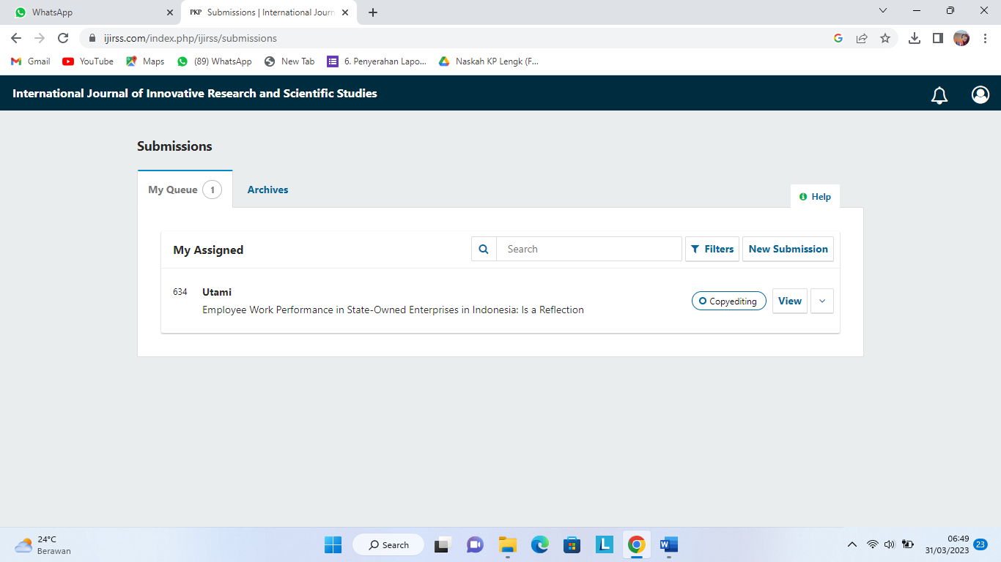
PENERIMAAN SUBMISI
22 September 2022

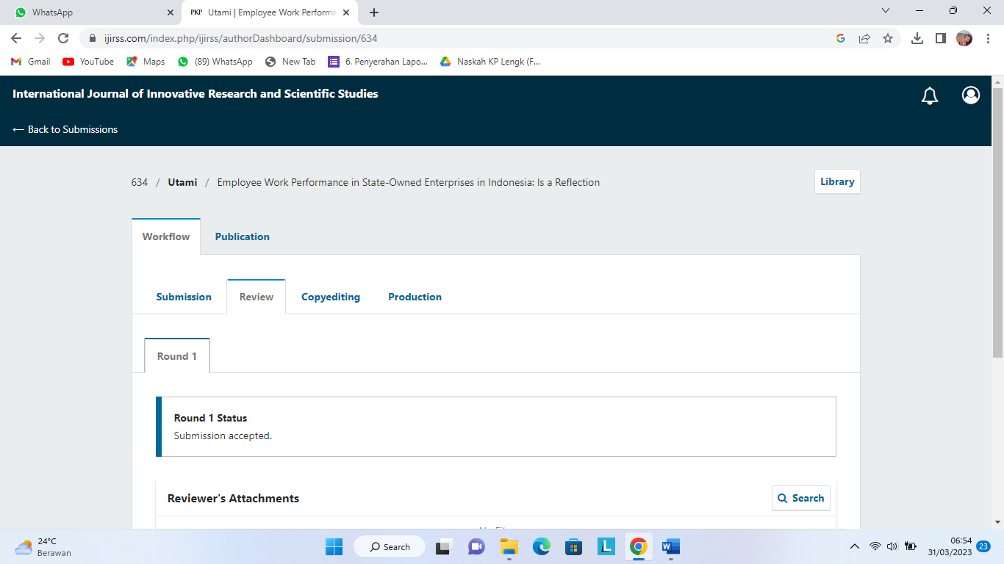

HASIL REVIEW
5 OKTOBER 2022

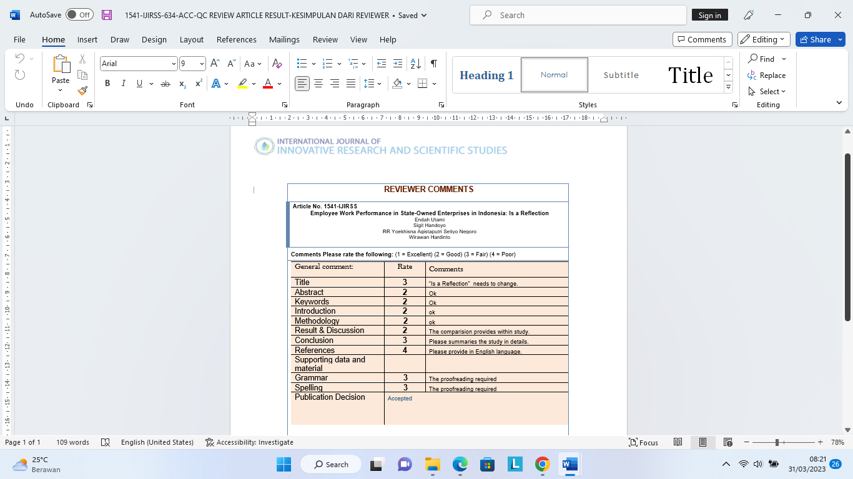

PROSES REVISI
6 OKTOBER 2022

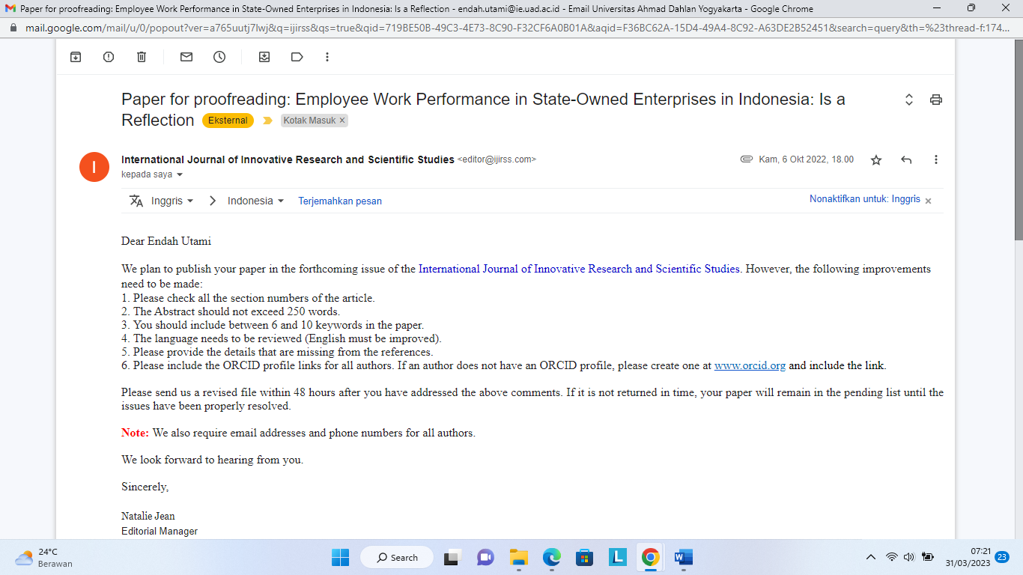

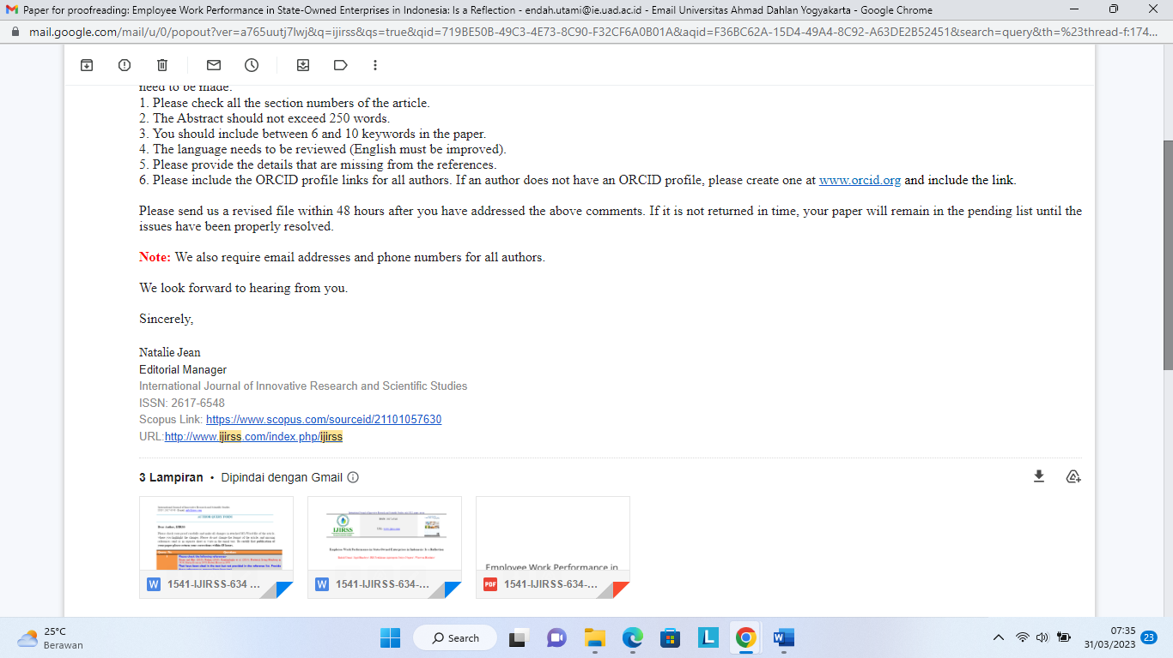

AUTHOR QUERY FORM

Dear Author, IJIRSS
Please check your proof carefully and make all changes in attached MS-Word file of the article, where you highlight the changes. Please do not change the format of the article, and missing references send us in separate sheet or write in the email text. To certify fast publication of your paper please return your corrections within 48 hours.
Query- No. | Questions
1 | Please check the following references-  Dixon and Hart (2010), Farhan (2018), Kantiandagho et al. (2014), Frederick Irving Herzberg in 1959, Martin Evans in 1970, Robert House in 1970  That have been cited in the text but not provided in the reference list. Provide these reference or remove them from text.
3 | In these references, Please add missing volume number, issue number and page no.  List of References  [29] F. Luthans, Organizational behaviour: Mcgraw-Hill, 2005.  [35] H. Pasolong, Public administration theory: Alphabet, 2007.  [54] D. F. Thomas Ng, How broadly does education contribute to job performance?: Wiley Periodicals, Inc, 2009.
4 | Please complete properly the cited references of book review, working paper and conference paper. You will need to properly check the publisher, publisher country name, page no. List of References  [1] A. Potu, "Leadership, motivation and work environment influence on employee performance at the regional office of the directorate general of State Assets, North Sulawesi and Maluku, Manado," EMBA Journal, vol. 1, 2013.  [2] A. Pangarso and P. Susanti, "The effect of work discipline on employee performance in the basic social service bureau of the regional secretariat of West Java province," Journal of Theoretical and Applied Management, vol. 9, p. 147, 2017.  [7] T. Widodo, "The influence of the work environment, organizational culture, leadership on performance (Study on Employees of Sidorejo District, Salatiga City)," Scientific Journal Among Makati, vol. 3, 2010.  [10] D. S. Trang, "Leadership style and organizational culture influence on employee performance (Study on BPKP Representative of North Sulawesi Province)," EMBA Journal, vol. 1, p. 1640, 2013.  [12] I. Brahmasari and A. Suprayetno, "The influence of work motivation, leadership and organizational culture on employee job satisfaction and its impact on company performance (Case Study at PT. Pei Hai International Wiratama Indonesia)," Journal of Management and Entrepreneurship, vol. 10, 2008.  [28] D. Lina, "Analysis of the influence of leadership and organizational culture on employee performance with the reward system as a moderating variable," Journal of Accounting and Business Research, vol. 14, 2014.  [39] Y. Tongo, "The influence of leadership style and work discipline on the performance of members of the detachment a pelopo unit of the police mobile brigade," Journal of Business and Management Research, vol. 2, 2014.

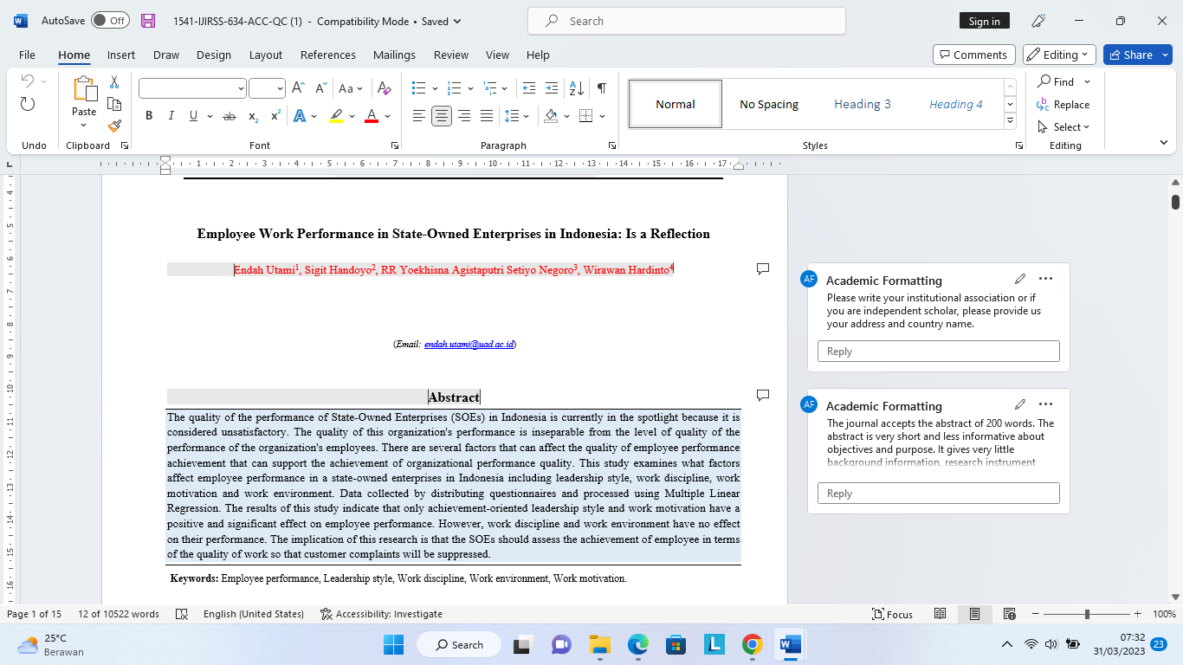

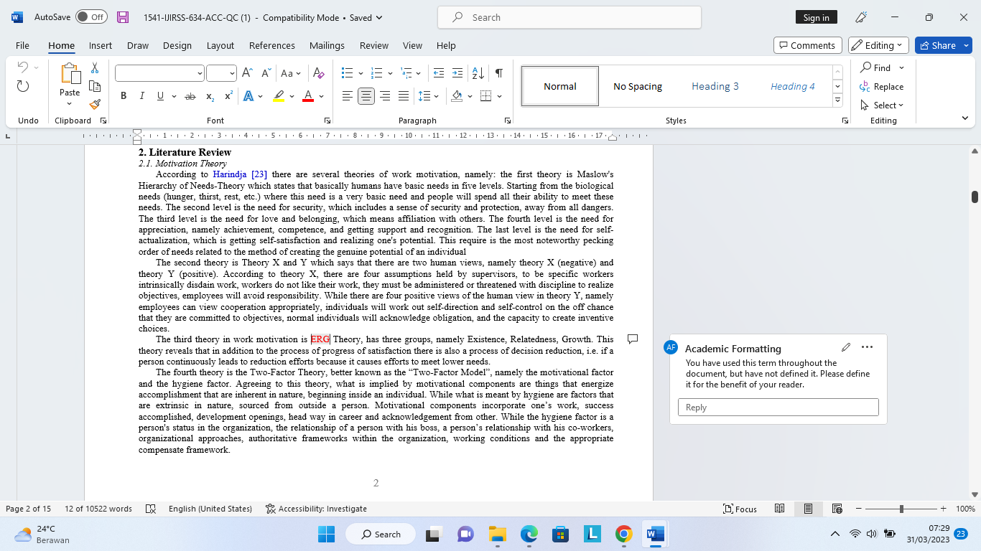

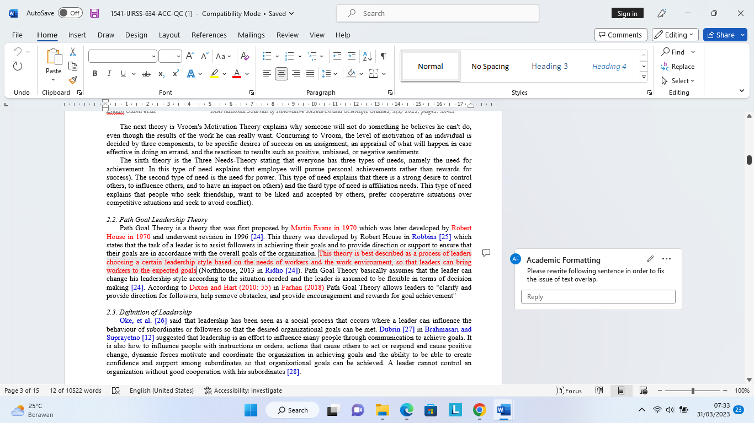

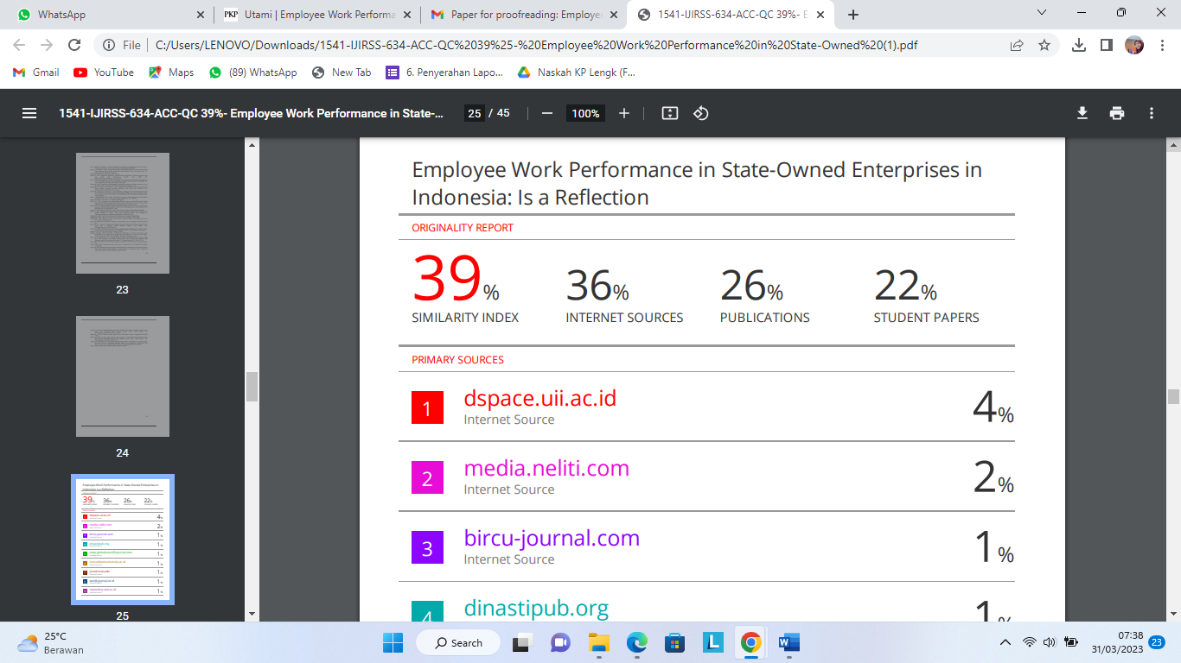

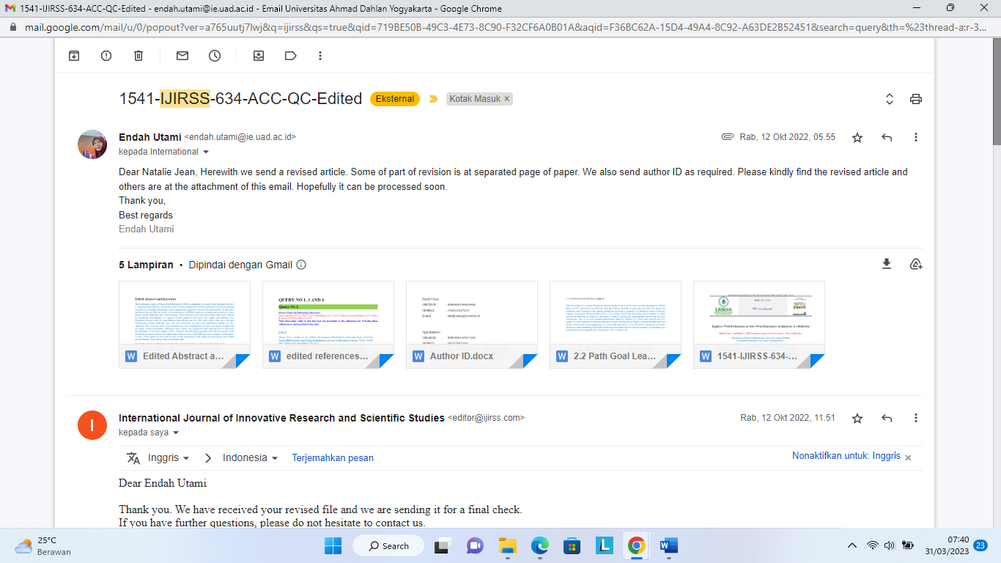

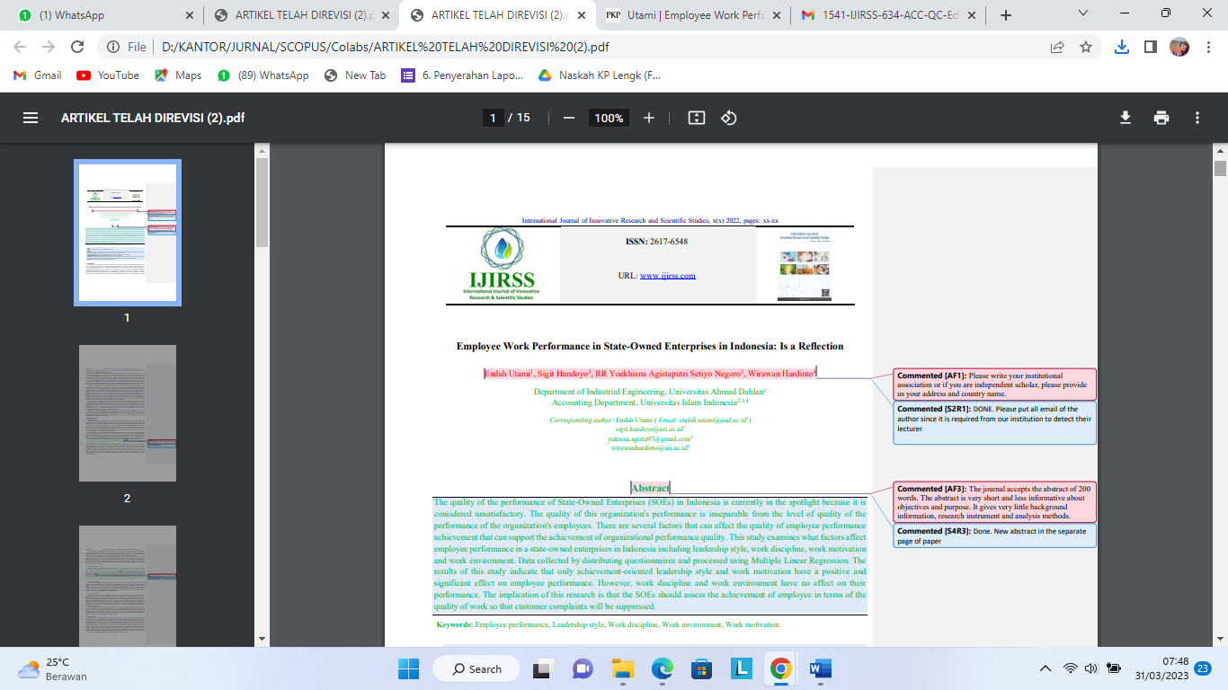

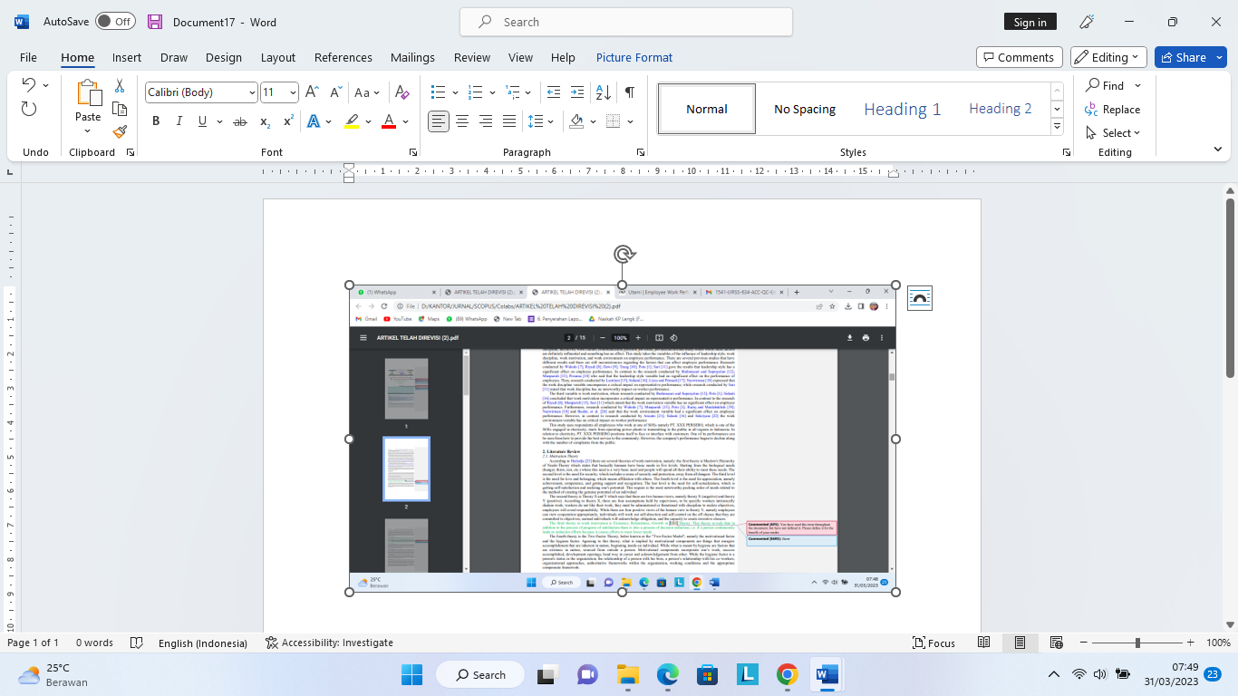

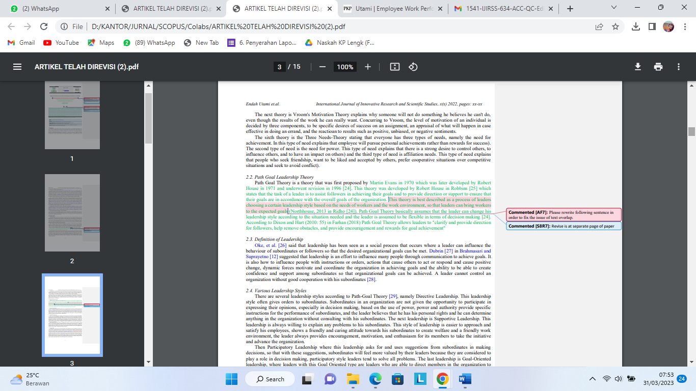

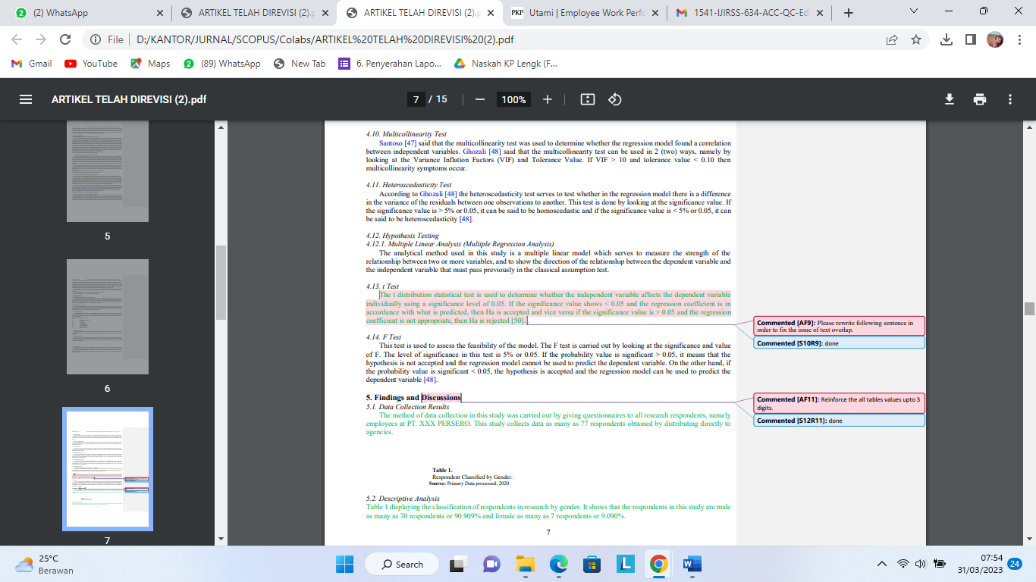

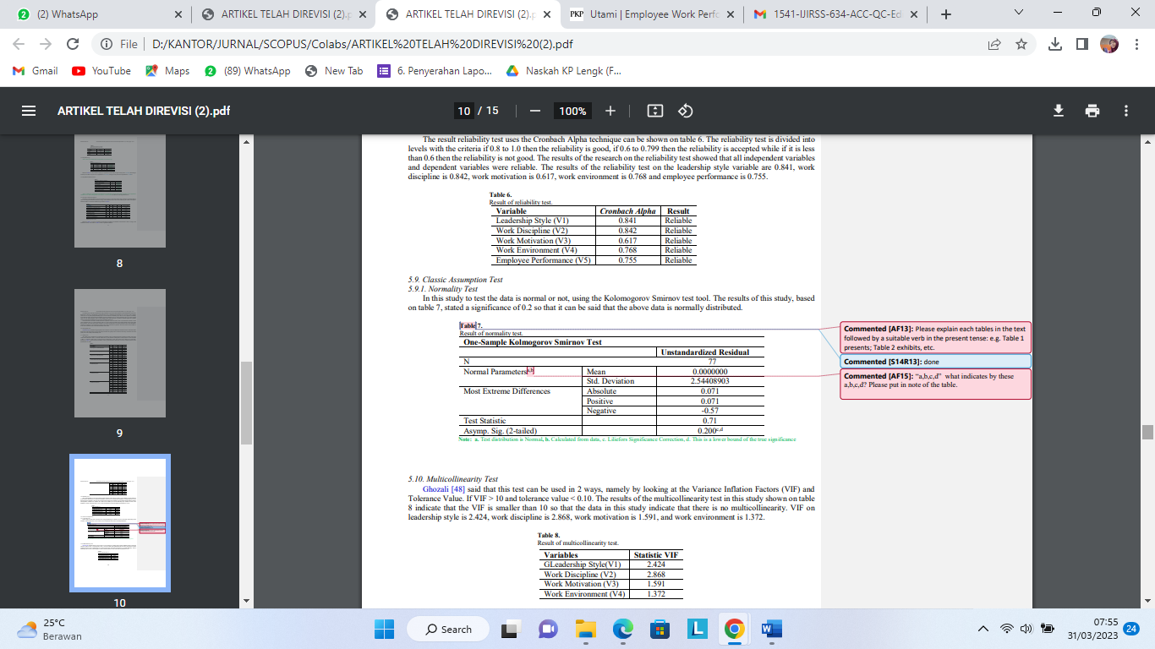

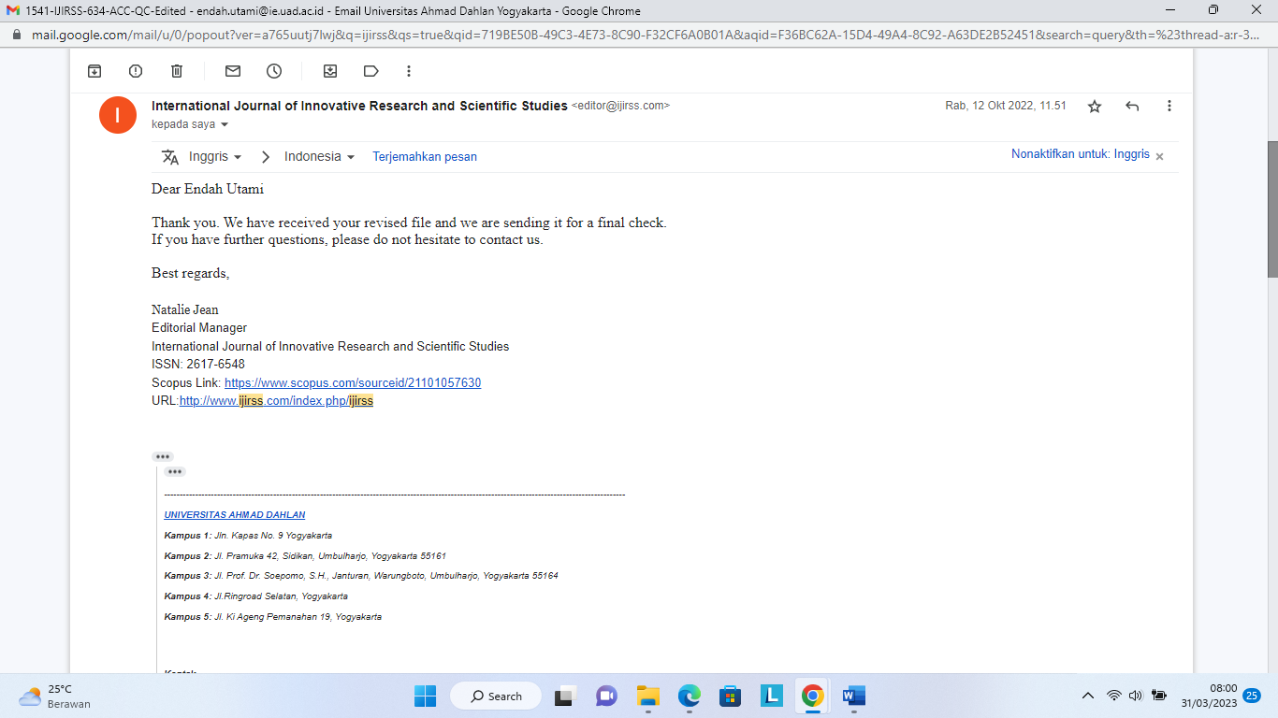

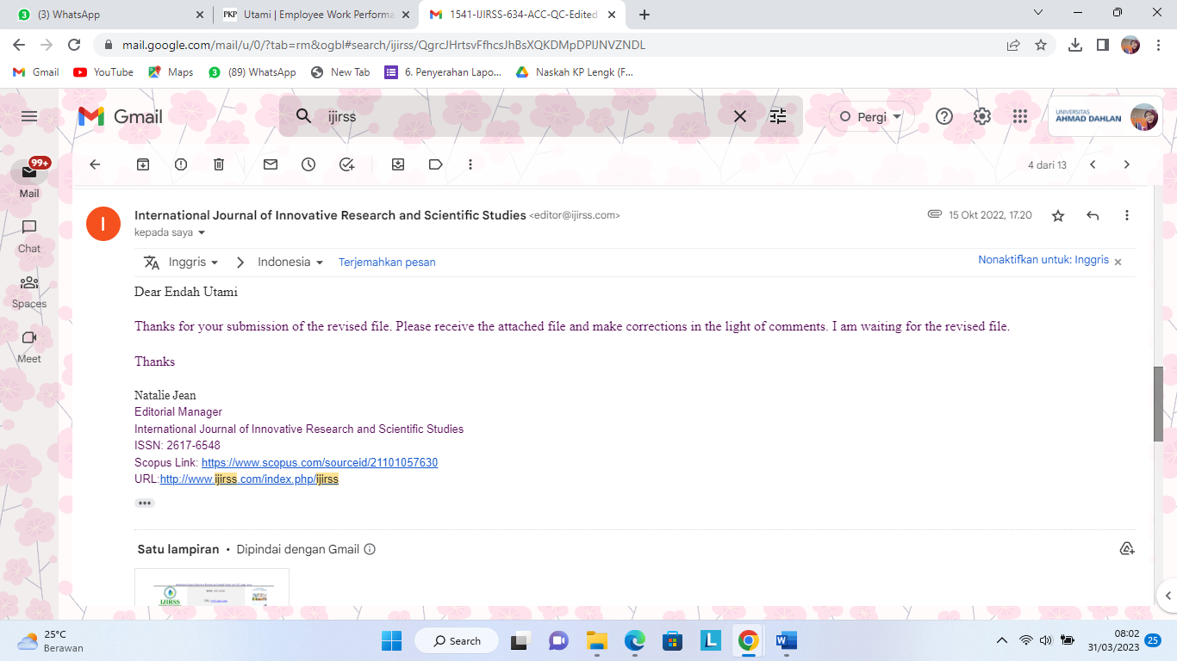

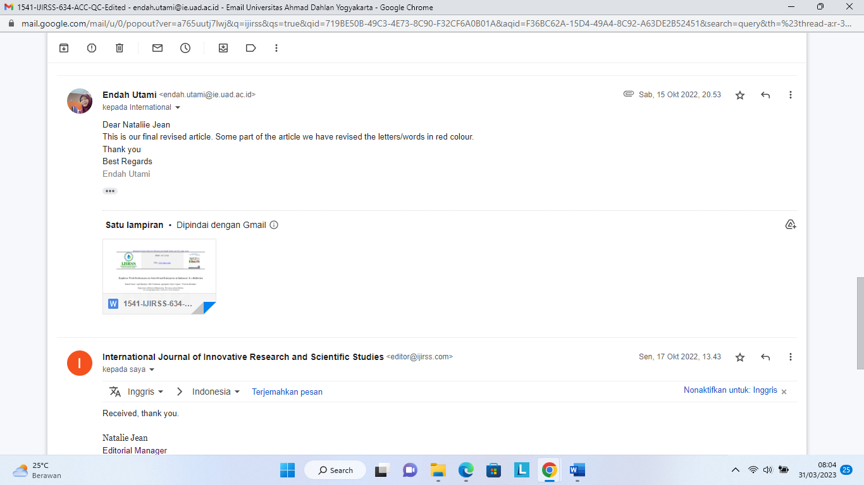

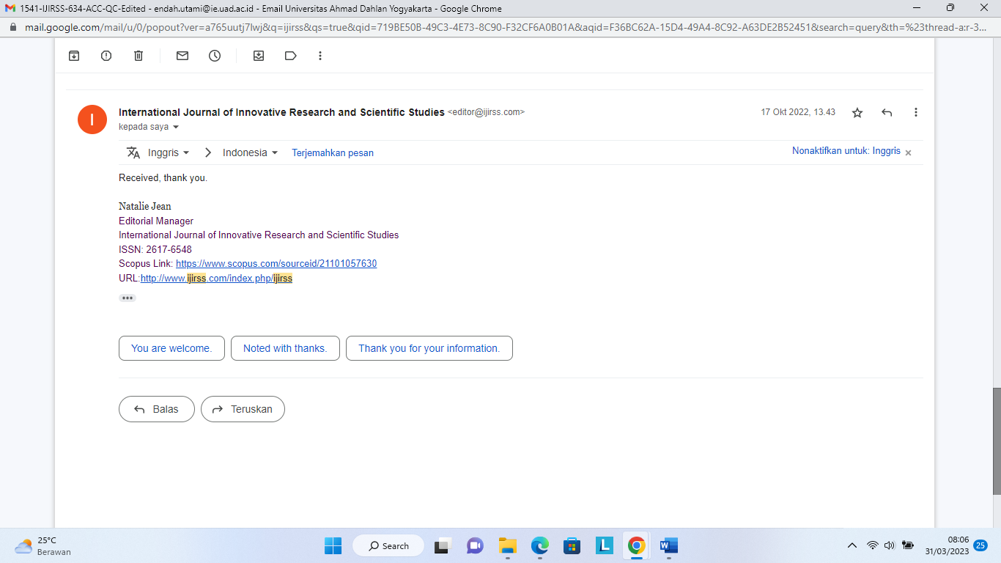

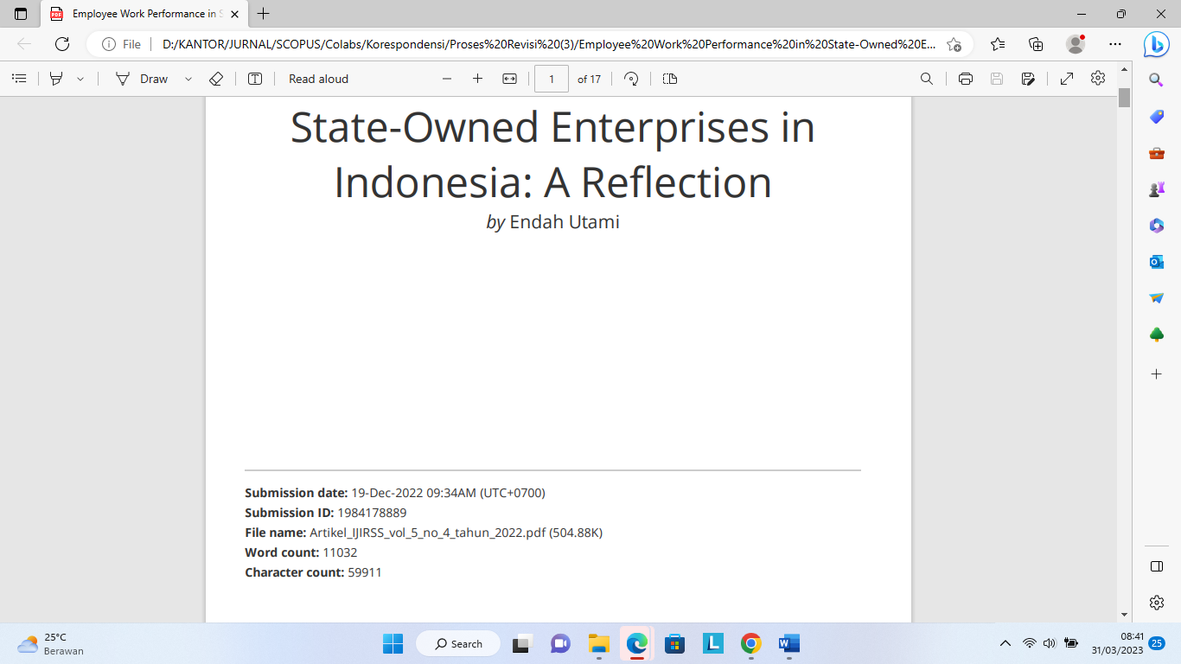
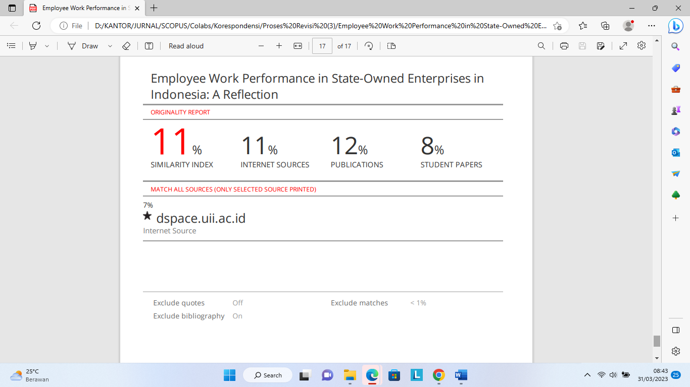

ACCEPTED
22 SEPTEMBER 2022

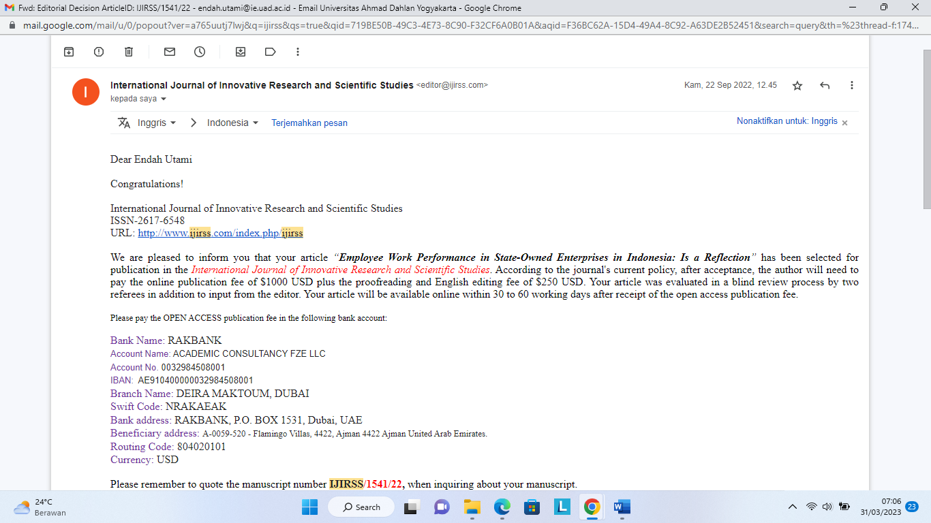

PUBLISHED
31 OKTOBER 2022

