THE DEAN OF FACULTY OF TEACHER TRAINING AND EDUCATIONUNIVERSITASAHMAD DAHLAN

Considering | : | 1. | ThatthequalityofAdministrationandAcademicActivitiesofThesisWritingatMasterProgramofEnglishLanguageEducation,itisnecessarytoappointMaster  ThesisSupervisorinAccordance withTheUniversityRegulations;
 | : | 2. | ThatthelecturersmentionedbelowhavemettheRequirementsforMaster’sThesis  FinalExamination.

Referringto | : | 1. | TheStatuteandLawofMuhammadiyah;
 |  | 2. | TheQaedaMuhammadiyahUniversities;
 |  | 3. | TheDecisionofMuhammadiyahCouncilforHigherEducationandDevelopment  No:342/KEP/I.3/D/2008.
 |  | 4. | MoUbetweenUADand USANTdatedDecember 15,2019,point1.1.
 |  | 5. | MoUbetweenUADandUiTMdated May5,2021,Article2 point2.1.b

DECIDED

Toissuethe :AppointmentOfVivaVocePanelForJointThesisWritingWithTheFollowingComposition;

No | Name | Position
1 | Dr.IinInawati,M.Pd. | Chairperson
2 | Prof.Dr.EstrellaT.Arroyo | Examiner1
3 | Dr.MarilouD.Tino | Examiner2
4 | Assoc.Prof.Dr. KamisahAriffin,Ph.D. | Secretary

ForthefollowingMaster’sCandidate:
Name | : | RaniZahra
SdtId | : | 2008042023
StudyProgram | : | MasterofEnglishLanguageEducation
Dayand date | : | Thursday,November17,2022
Venue | : | ZoomMeeting
Timeslot | : | 10:15-11:00(Malaysia/PhilipineTime)
Thesistitle | : | GENDERBIAS IN INDONESIAN SELECTED ENGLISH  TEXTBOOKSFORJUNIORHIGHSCHOOL:ACONTENTANALYSIS

ThisLetterofAppointmentis madeandcomeintoeffectonNovember15th,2022.

Given:Yogyakarta
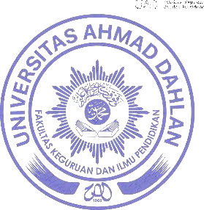
Dated : 15th of November, 2022Dean
Muhammad Sayuti, M.Pd., M.Ed., Ph.D.NIY.60080551

