**Digital Fundraising Zakat: A Study on the Impact of** **Social Media Marketing and** **Crowdfunding**

**Hilma Fanniar Rohman1*, Amrullah2, Muhammad Ridha3**

1,2 Islamic Banking, Universitas Ahmad Dahlan, Yogyakarta, Indonesia [1]

3 Primary School Teacher Education Study Program, Universitas Ahmad Dahlan, Yogyakarta, Indonesia

* [hilma@pbs.uad.ac.id](mailto:hilma@pbs.uad.ac.id)

**Abstract**

**Introduction to The Problem:** Zakat is an obligation for a Muslim or a body that has met the requirements (Nisab and haul). Islam obliges to pay it to amil zakat institutions. The potential of a large Muslim population in Indonesia is directly proportional to the existing potential. However, the national zakat revenue is not proportional to the existing potential. the development of technology is accelerating and we are entering the digital era causing Digital Fundraising Zakat to have an important role in the developments that occur in the dynamics of Zakat Fund Raising. Social Media Marketing and Crowdfunding Platform have an important role in Digital Fundraising Zakat.

**Purpose/Objective Study:** This study aims to analyze Social Media Marketing and crowdfunding Platforms on the Decision to pay zakat in Ciamis Regency.

**Design/Methodology/Approach:** The population of this research is all Muzakki in Ciamis Regency, while the sample is all Muzakki managers in Ciamis Regency who are under the auspices of Lembaga Amil Zakat Infaq Shadaqah Muhammadiyah Ciamis. Data was collected through questionnaire instruments and analyzed using descriptive statistical analysis techniques and Structural Equation Model (SEM) analysis.

**Findings:** Based on the results of data analysis, social media marketing, and crowdfunding platforms are proven to have a significant and positive influence on people's decision to give zakat. This research has shown that the strategy of zakat institutions that utilize digital technology influences optimizing zakat collection.

**Paper Type:** Research Article

**Keywords:** Digital Fundraising; Social Media Marketing; Crowdfunding; Zakat Management.

**Introduction**

The development of technology and digitalization has brought great changes in various aspects of life including in the collection of zakat, infaq, sadaqah and waqf funds. Some Amil Zakat institutions have used digital technology in the process of collecting these funds. However, until now the amount of funds collected through digital platforms has not reached the total amount of funds collected through conventional direct collection methods. At the end of the paragraph, the author/s should end with a comment on the significance concerning the identification of the issue and objective of the research (A. Hamid et al., 2020). The potential of zakat in Indonesia is huge, but there are still challenges in maximizing zakat collection effectively.

The central authority, in this case Baznas, must encourage stakeholders in Indonesia to create a collaborative strategy for providing digital fundraising services. Collaboration can increase the trust felt by the community (Aji et al., 2021). The use of social media to campaign through digital means can support inclusive marketing theory, as well as being able to increase awareness of religious obligations to fulfill Zakat (Hudaefi & Beik, 2020).

The young generation, especially Gen-Z, is highly interested in using digital platforms for zakat payment for several reasons. Starting from the sense of innovation, security, and privacy risks (Oktavendi & Mu’ammal, 2022). The system that makes it easy for people to make zakat payments through an online platform (user-friendly) is found to be the most important one that affects the intention to pay zakat online (Kasri & Yuniar, 2021).

In addition to social media, the use of crowdfunding platforms can also predict the future, in this case, the interest of the Islamic community (Testa et al., 2022). Currently, many zakat institutions in Indonesia have begun to utilize crowdfunding platforms to facilitate the process of collecting zakat funds. The use of crowdfunding platforms not only makes it easier for Muzzaki but also makes it easier for Amil and Mustahik (Herianingrum et al., 2022).

Digital-based services such as e-commerce payment channels, crowdfunding, digital payment engines, and QR codes help Muzakki pay zakat, accelerate the value of zakat received by Mustahik, and make management easier (Widiastuti et al., 2021). Personal communication does not provide significant motivation to a person's interest in paying Zakat (Pangestu & Jayanto, 2017). Digital Technology Usage Habits affect the Preference of users to pay Zakat through Technology (Bin-Nashwan et al., 2023).

The perceived convenience factor will increase the public's intention to use the mobile zakat service and use it in regular zakat payments. However, there are still some challenges in the use of digital fundraising, such as the lack of public awareness of the available digital platforms and also trust in the security and reliability of these platforms (Muflih, 2023).

The use of technology will increase the privacy and security of the Zakat Giver. With increased security and privacy, it will reduce the risk of technology adaptation. The use of technology can also increase public trust due to more open data (Bin-Nashwan et al., 2023). Crowdfunding and digitalization are therefore effective zakat models (Mahomed, 2022).

This research aims to identify the effectiveness of social media marketing and the influence of crowdfunding in fundraising by Amil Zakat institutions. This research is important in addition to contributing to the current discourse on the digitalization of zakat management, as well as providing practical benefits as material for assessing and improving the process of zakat management through digital media.

Social media has become an effective tool in promoting good causes, including encouraging people to give zakat. (Agustina, 2021) Empirically, it shows that social media marketing has a positive influence on the interest of muzakki to pay zakat. The decision to pay zakat by muzakki is influenced by the trust factor in the zakat management institution that arises from the openness of zakat management informed on social media. The same findings were also presented by (Marhusin & Taharuddin, 2023) (Amrina & Fahrullah, 2021) explaining that the use of digital marketing utilizing social media has generated public interest and increased the collection of ZIS (zakat, infaq and sadaqah).

H1. Social media marketing has a significant positive impact on customer decisions to give zakat.

Research (Hasna & Irwansyah, 2019) shows that the innovation of the crowdfunding platform has a positive impact on the decision to donate. Crowdfunding technology innovation allows people to donate more easily and quickly. In addition, the perception of people who believe that crowdfunding platforms have benefits and can be trusted has a positive impact on people's behavior toward distributing zakat (Destrianti & Baskoro, 2020). (Putri & Anwar, 2021) shows that the accessibility of the crowdfunding platform significantly positively affects the distribution of zakat infaq and sadaqah online. The effectiveness of zakat distribution through crowdfunding also encourages muzakki's interest in giving zakat through this technology (Rohmah et al., 2020). so that the presence of a crowdfunding platform as an alternative to zakat distribution can encourage the optimization of zakat collection.

H2. Crowdfunding platforms have a significant positive impact on customer decisions to give zakat.

**Methodology**

The approach used in the research is quantitative. Quantitative research methods are research methods used to research certain populations or samples, data collection using research instruments, and statistical or quantitative data analysis, with a vision to test predetermined hypotheses (Sugiyono, 2016). The population in this case is Muzakki who distributes Zakat funds in 10 LAZISMU Ciamis Offices consisting of 9 (Nine) LAZISMU Ciamis Service Offices and LAZISMU Ciamis Regional Office. From a population of 214 Muzakki, a sample of 100 Muzakki was taken. Data was obtained from respondents by filling out questionnaires, observations, and interviews. Data analysis applies statistical tests and hypothesis tests. Data was collected through questionnaire instruments and analyzed using descriptive statistical analysis techniques and Structural Equation Model (SEM) analysis.

**Figure 1.** Variables Model

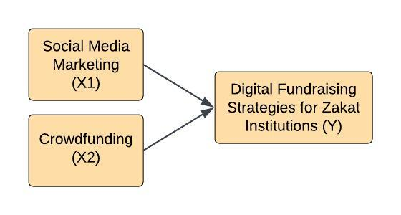

**Table 1.** Variables, Indicators, and Sources

|  |  |  |
| --- | --- | --- |
| **Variables** | **Indicators** | **Source** |
| Social Media Marketing (X1) | • Online communities  • Interaction  • Sharing of content  • Accessibility  • credibility | (As’ad & Alhadid, 2014) |
| Crowdfunding (X2) | • Knowledge  • Persuasion  • Decision | (Hasna & Irwansyah, 2019) |
| Digital Fundraising Strategies for Zakat Institutions (Y) | • Zakat Collection  • Management of Zakat  • Distribution of Zakat | (Santoso, 2019) |

**Results and Discussion**

Based on Cronbach's alpha parameter with a rule of thumb >0.70 (Savitri et al., 2021), the reliability of each latent variable is >0.70. While the reliability test with the Composite Reliability parameter> 0.70) (R. S. Hamid & Anwar, 2019), Composite reliability (rho_a) data> 0.70, then each latent variable has good reliability.

**Table 2.** Composite Reliability Variable

|  |  |  |  |  |
| --- | --- | --- | --- | --- |
|  | **Cronbach’s Alpha** | **rho_a** | **rho_c** | **AVE** |
| Social Media | 0.867 | 0.869 | 0.896 | 0.521 |
| Crowdfunding | 0.913 | 0.917 | 0.929 | 0.623 |
| Zakat Decision | 0.910 | 0.911 | 0.928 | 0.650 |

*Source: data processed results, 2024*

Based on (R. S. Hamid & Anwar, 2019) Rul of Thumb R Square, the R Square value is 0.70 (Strong), 0.50 (Moderate), and 0.25 (Weak), then 0.822 is included in the strong classification. This indicates that the Social Media and Crowdfunding variables can explain the variable of the decision to give zakat by 82.2%.

**Table 3.** R-Square

|  |  |  |
| --- | --- | --- |
|  | **R-Square** | **R-Square Adjusted** |
| Zakat Decision | 0.822 | 0.819 |

*Source: data processed results, 2024*

**Table 4.** Hypothesis Test Results

|  |  |  |  |  |  |
| --- | --- | --- | --- | --- | --- |
|  | **Original sample (O)** | **Sample mean (M)** | **Standard deviation (STDEV)** | **T statistics (|O/STDEV|)** | **P values** |
| Social Media -> Zakat Decision | 0.145 | 0.149 | 0.069 | 2.104 | 0.035 |
| Crowdfunding -> Zakat Decision | 0.784 | 0.779 | 0.061 | 12.911 | 0.000 |

*Source: data processed results, 2024*

The explanation is as follows:

1. The Social Media variable obtained a statistical t value of 2.104> 1.96 or P Values 0.035 <0.05, so H1 is accepted, namely, Crowdfunding affects the decision to give zakat.
2. The Crowdfunding variable obtained a statistical t value of 12.911> 1.96 or a P value of 0.000 <0.05, so H2, namely Crowdfunding, affects Tithing Decisions.

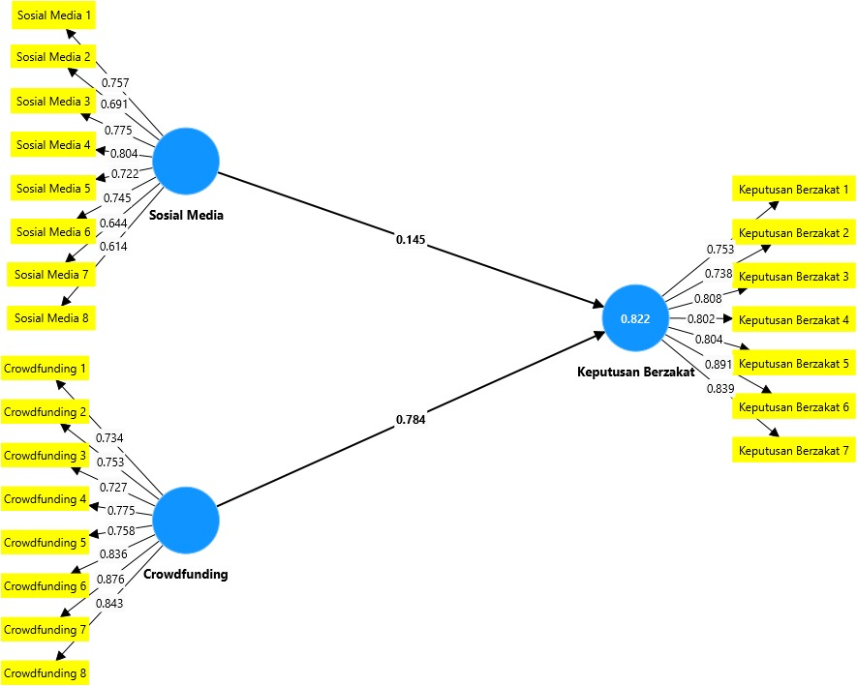

***Social Media Marketing Affects the Optimisation of Zakat Collection***

Based on the analysis results above, Social media marketing has a positive and significant influence on the decision to give zakat. With an increase in the decision to give zakat, the optimization of zakat collection will also increase. This finding is in line with research conducted by (Agustina, 2021) (Marhusin & Taharuddin, 2023) and (Amrina & Fahrullah, 2021). Social media is an effective means to campaign for the invitation to give zakat as well as to establish more intensive communication with the public, especially prospective muzakki who want to give zakat. Quality social media content can present interesting and informative information. In addition, social media allows accessibility and openness of zakat management information carried out by zakat institutions. This increases the trust of muzakki or prospective muzakki to distribute zakat.

***Crowdfunding Platform Affects Optimisation of Zakat Collection***

Based on the findings above, it can be said that the crowdfunding platform has a significant positive influence on the decision to give zakat. The use of crowdfunding technology with all its potential can be a means to optimize zakat collection. This is in line with the findings of (Destrianti & Baskoro, 2020; Hasna & Irwansyah, 2019; Putri & Anwar, 2021; Rohmah et al., 2020). Crowdfunding platforms provide convenience and fast facilities for donations, including zakat. Innovation and crowdfunding systems are also considered trustworthy in the management of Zakat, thus encouraging people to use its facilities.

**Conclusion**

This research has shown that the strategy of zakat institutions that utilize digital technology influences optimizing zakat collection. Based on the results of data analysis, social media marketing, and crowdfunding platforms are proven to have a significant and positive influence on people's decision to give zakat. Utilization of the potential owned by social media and crowdfunding will encourage the optimization of the digital zakat collection. Social media is an effective means of communication and invitation to the public to give zakat, with an attractive display of information. In addition, the ease of access and openness of zakat management information presented on social media will increase public trust in zakat institutions. This will encourage people to give zakat without hesitation. A crowdfunding platform is a technological innovation that becomes an alternative to zakat distribution. It is beneficial for muzakki to be able to pay their zakat obligations quickly and easily. Considering the great potential of social media marketing and crowdfunding platforms in optimizing digital zakat collection, it is expected that zakat institutions begin to consider its use and continue to develop it for the better in the future.

**References**

Agustina, H. (2021). *Pengaruh Digital Marketing terhadap Keputusan Berzakat pada Badan Amil Zakat Nasional (BAZNAS) Pusat*.

Aji, H. M., Albari, A., Muthohar, M., Sumadi, S., Sigit, M., Muslichah, I., & Hidayat, A. (2021). Investigating the determinants of online infaq intention during the COVID-19 pandemic: an insight from Indonesia. *Journal of Islamic Accounting and Business Research*, *12*(1), 1–20. https://doi.org/10.1108/JIABR-05-2020-0136

Amrina, M., & Fahrullah, A. (2021). Penerapan Strategi Digital Marketing dalam Meningkatkan Penghimpunan Dana ZIS (Zakat, Infaq, dan Shodaqoh) di Laznas IZI Jawa Timur. *Jurnal Ekonomika Dan Bisnis Islam*, *4*(1), 124–138. https://doi.org/10.26740/jekobi.v4n1.p124-138

As’ad, H. A.-R., & Alhadid, A. Y. (2014). The Impact of Social Media Marketing on Brand Equity: An Empirical Study on Mobile Service Providers in Jordan. *Review of Integrative Business and Economics Research*, *3*(1), 315–345. https://www.proquest.com/scholarly-journals/impact-social-media-marketing-on-brand-equity/docview/1513215316/se-2?accountid=188440

Bin-Nashwan, S. A., Shah, M. H., Abdul-Jabbar, H., & Al-Ttaffi, L. H. A. (2023). Social-related factors in integrated UTAUT model for ZakaTech acceptance during the COVID-19 crisis. *Journal of Islamic Accounting and Business Research*. https://doi.org/10.1108/JIABR-02-2022-0038

Destrianti, G., & Baskoro, B. D. (2020). *Penggunaan Platform Crowdfunding dalam Menyalurkan Zakat, Infaq, dan Shadaqah (ZIS): Studi Intensi Masyarakat*. *2*(2), 95–109. https://doi.org/10.46918/point.v2i2.748

Hamid, A., Agus, B., & Siti, R. N. (2020). *Amil di era digital*. Filantropi Indonesia.

Hamid, R. S., & Anwar, S. M. (2019). *Structural Equation Modeling (SEM) Berbasis Varian: Konsep Dasar dan Aplikasi dengan ProgramSmartPLS3.2.8 dalam Riset Bisnis*. PT Inkubator Penulis Indonesia.

Hasna, S., & Irwansyah. (2019). Pengaruh Inovasi Crowdfunding Terhadap Keputusan Berdonasi. *Digital Zone: Jurnal Teknologi Informasi Dan Komunikasi*, *10*(2), 144–156. https://doi.org/10.31849/digitalzone.v10i2.2719

Herianingrum, S., Widiastuti, T., Hapsari, M. I., Ratnasari, R. T., Firmansyah, F., Hassan, S. A., Febriyanti, A. R., Amalia, R. C., & Muzakki, L. A. (2022). Muzakki and Mustahik’s collaboration model for strengthening the fundraising capacity of Islamic social finance institutions during COVID-19. *International Journal of Ethics and Systems*. https://doi.org/10.1108/IJOES-05-2022-0091

Hudaefi, F. A., & Beik, I. S. (2020). Digital zakāh campaign in time of Covid-19 pandemic in Indonesia: a netnographic study. *Journal of Islamic Marketing*, *12*(3), 498–517. https://doi.org/10.1108/JIMA-09-2020-0299

Kasri, R. A., & Yuniar, A. M. (2021). Determinants of digital zakat payments: lessons from Indonesian experience. *Journal of Islamic Accounting and Business Research*, *12*(3), 362–379. https://doi.org/10.1108/JIABR-08-2020-0258

Mahomed, Z. (2022). Modelling Effective Zakat Management for the ‘Stans’ of Central Asia and Establishing Pandemic Resilience. *Towards a Post-Covid Global Financial System*, 143–159. https://doi.org/10.1108/978-1-80071-625-420210008

Marhusin, M., & Taharuddin, T. (2023). Pengaruh Social Marketing Terhadap Keputusan Berdonasi Yang Di Mediasi Oleh Kepercayaan Donatur Pada Badan Amil Zakat Nasional Provinsi Kalimantan Selatan. *Jurnal Bisnis Dan Pembangunan*, *12*(3), 79. https://doi.org/10.20527/jbp.v12i3.17988

Muflih, M. (2023). Muzakki’s adoption of mobile service: integrating the roles of technology acceptance model (TAM), perceived trust and religiosity. *Journal of Islamic Accounting and Business Research*, *14*(1), 21–33. https://doi.org/10.1108/JIABR-09-2021-0273

Oktavendi, T. W., & Mu’ammal, I. (2022). Acceptance model for predicting adoption of Zakat, Infaq, and Sodaqoh (ZIS) digital payments in Generation Z. *Journal of Islamic Accounting and Business Research*, *13*(4), 684–700. https://doi.org/10.1108/JIABR-09-2021-0267

Pangestu, I., & Jayanto, P. Y. (2017). Analysis in factors affecting muzakki motivation to pay zakat in Semarang city. *Accounting Analysis Journal*, *6(1)*(1), 94–103. https://journal.unnes.ac.id/sju/index.php/aaj

Putri, P. A., & Anwar, A. Z. (2021). Faktor yang Mempengaruhi Masyarakat dalam Menyalurkan Zakat, Infak, Sedekah Melalui Platform Crowfunding. *Stability: Journal of Management and Business*, *4*(2), 182–200. https://doi.org/10.26877/sta.v4i2.10975

Rohmah, I. L., Ibdalsyah, I., & Kosim, A. M. (2020). Pengaruh Persepsi Kemudahan Berdonasi, Dan Efektifitas Penyaluran Menggunakan Fintech Crowdfunding Terhadap Minat Membayar Zakat, Infaq, Shadaqoh. *Kasaba: Jurnal Ekonomi Islam*, *13*(1), 42–51.

Santoso, I. R. (2019). Strategy for Optimizing Zakat Digitalization in Alleviation Poverty in the Era of Industrial Revolution 4.0. *Ikonomika*, *4*(1), 35–52. https://doi.org/10.24042/febi.v4i1.3942

Savitri, C., Faddila, S. P., Irmawartini, I., Iswari, H. R., Anam, C., Syah, S., Mulyani, S. R., Sihombing, P. R., Kismawadi, E. R., Pujianto, A., Mulyati, A., Astuti, Y., Adinugroho, W. C., Imanuddin, R., Kristia, K., Nuraini, A., & Siregar, M. T. (2021). STATISTIK MULTIVARIAT DALAM RISET. In D. (c) I. Ahmaddien (Ed.), *CV WIDINA MEDIA UTAMA*. CV WIDINA MEDIA UTAMA.

Testa, S., Atawna, T., Baldi, G., & Cincotti, S. (2022). The innovation potential of Islamic crowdfunding platforms in contributing to sustainable development. *European Journal of Innovation Management*, *25*(6), 1008–1035. https://doi.org/10.1108/EJIM-11-2021-0547

Widiastuti, T., Cahyono, E. F., Zulaikha, S., Mawardi, I., & Al Mustofa, M. U. (2021). Optimizing zakat governance in East Java using analytical network process (ANP): the role of zakat technology (ZakaTech). *Journal of Islamic Accounting and Business Research*, *12*(3), 301–319. https://doi.org/10.1108/JIABR-09-2020-0307

1. ## Acknowledgment

   ## A big thank you goes to the Institute for Research and Community Service of Universitas Ahmad Dahlan (LPPM UAD) for sponsoring the preparation of this paper.

  