ARTIKEL LUARAN MAGANG

PENYUNTINGAN Akbar Wika Putra.pdf

*by* Paper Craft 24

Submission date: 16-Jan-2025 07:43AM (UTC-0500)

Submission ID: 2565225765

File name: ARTIKEL_LUARAN_MAGANG_PENYUNTINGAN_Akbar_Wika_Putra.pdf (156.24K)

Word count: 869

Character count: 5328

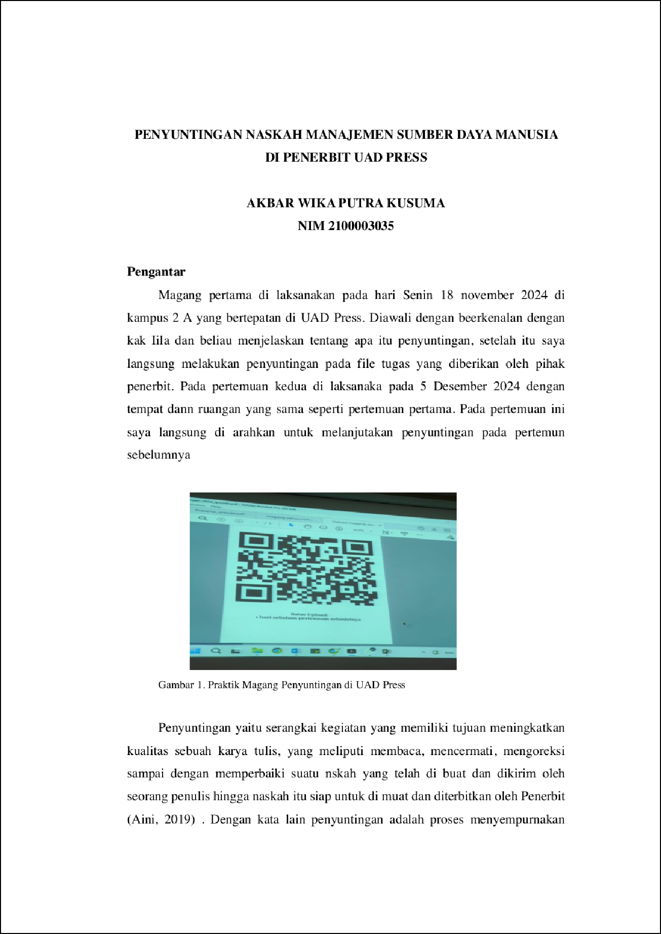

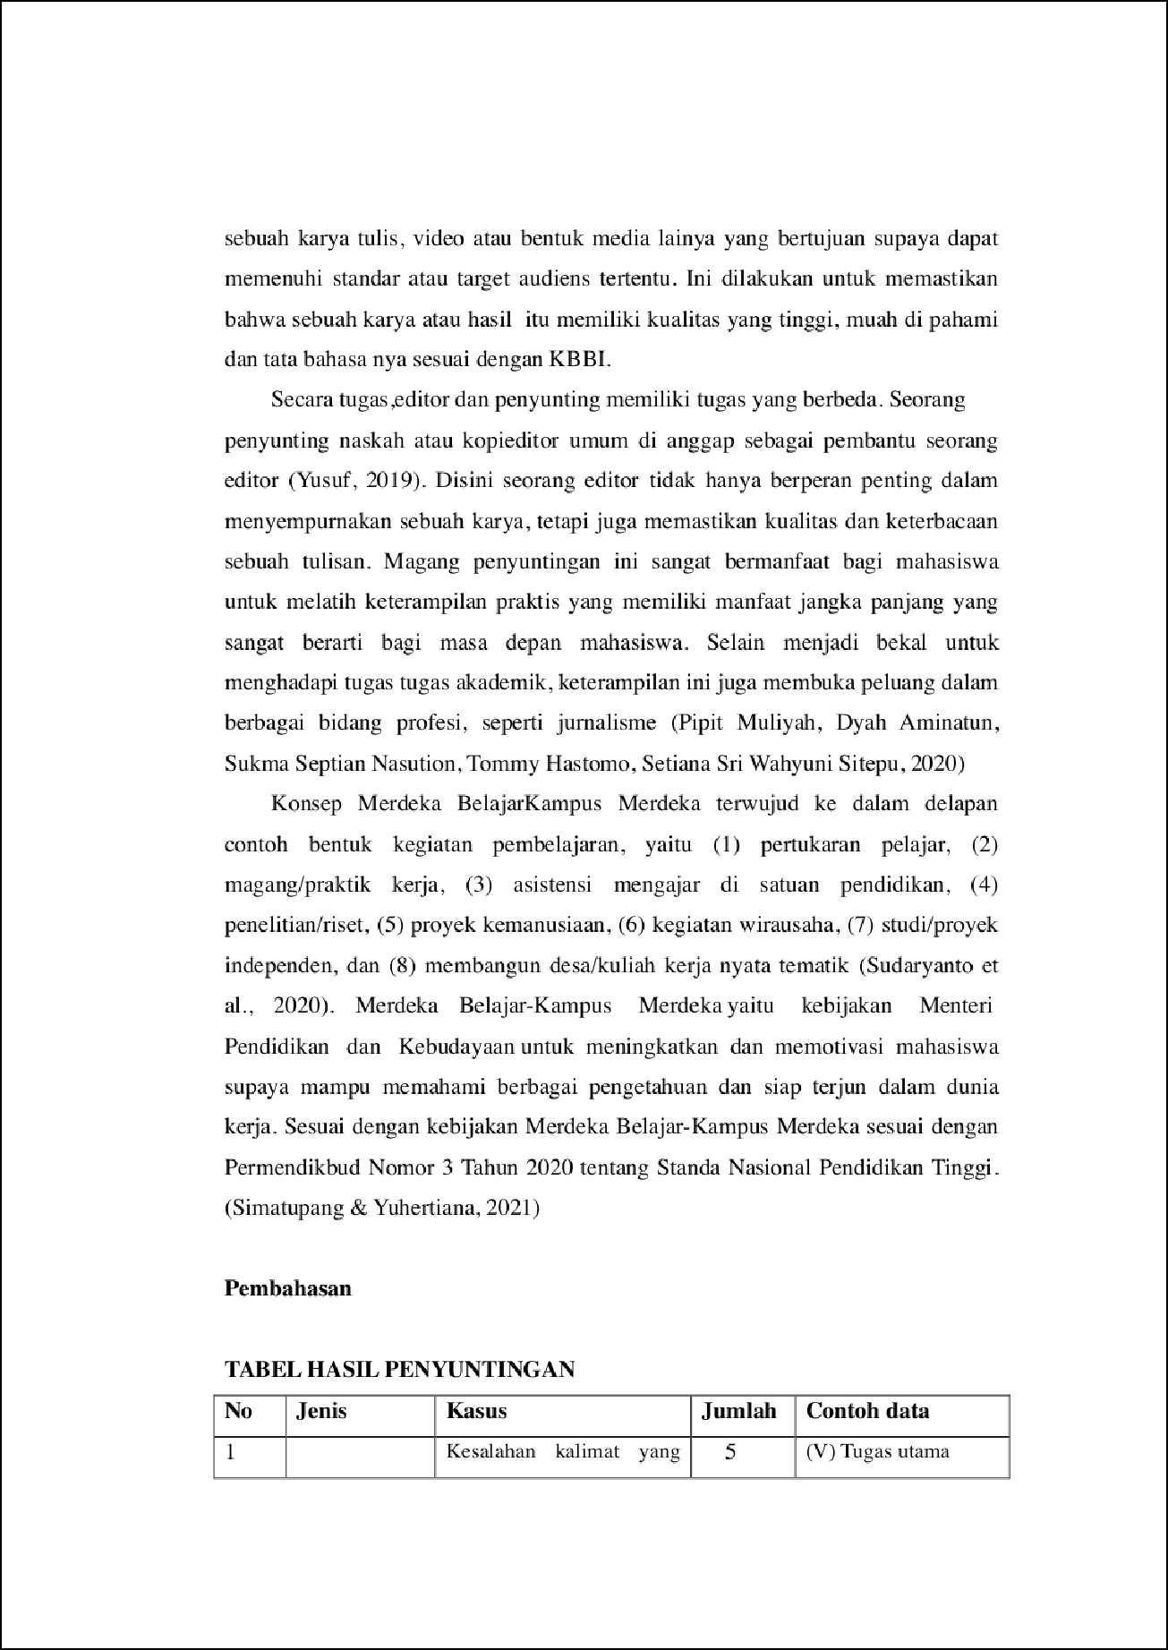

4

2

5

3

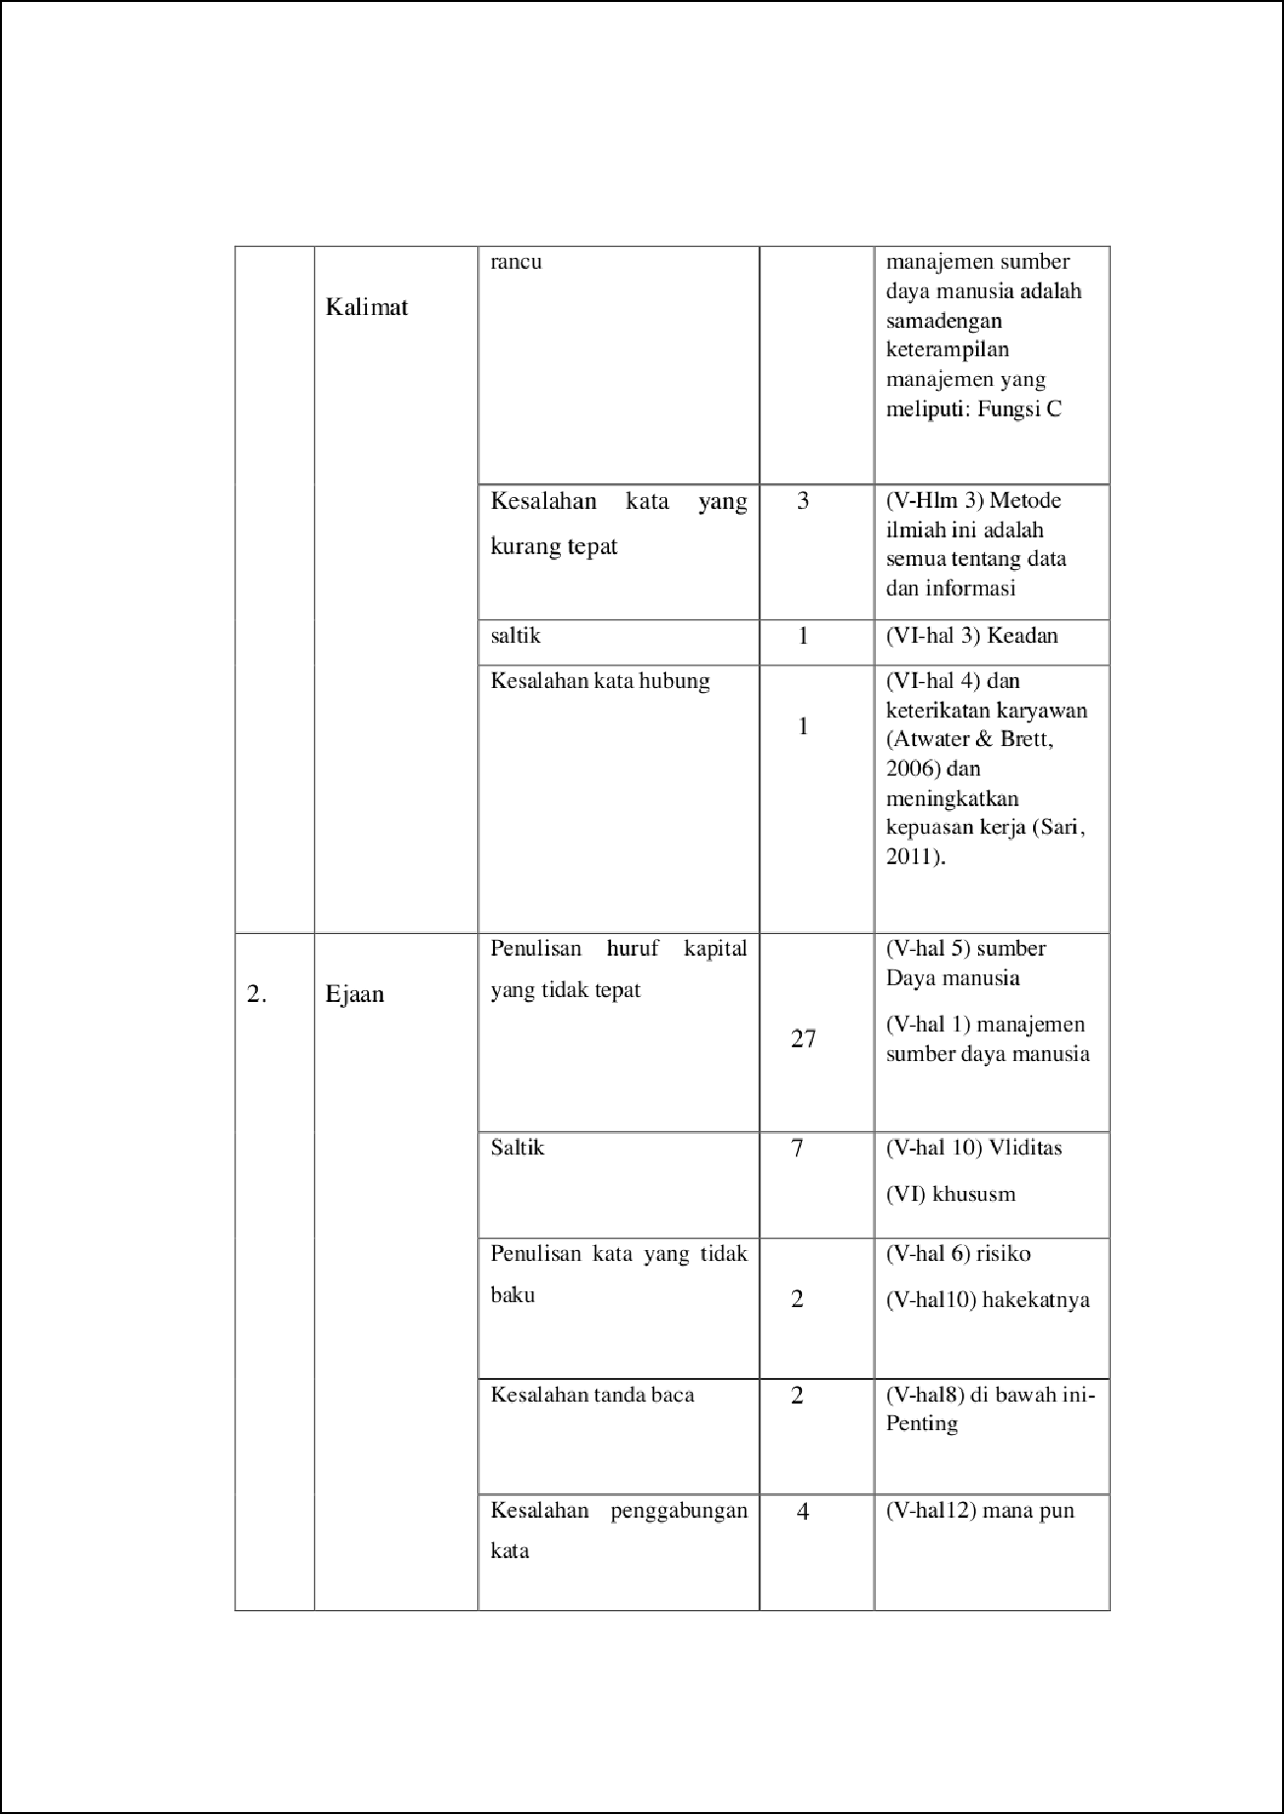

1

1

1

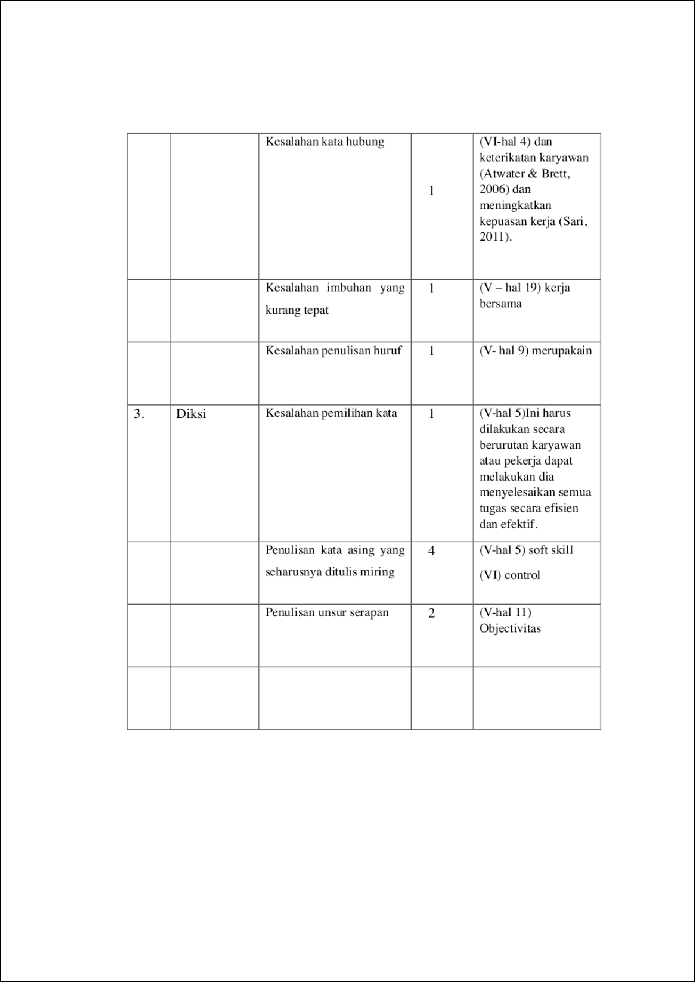

1

1

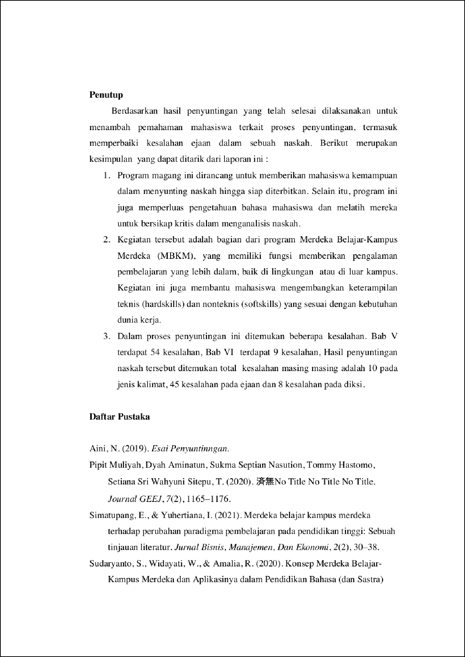

6

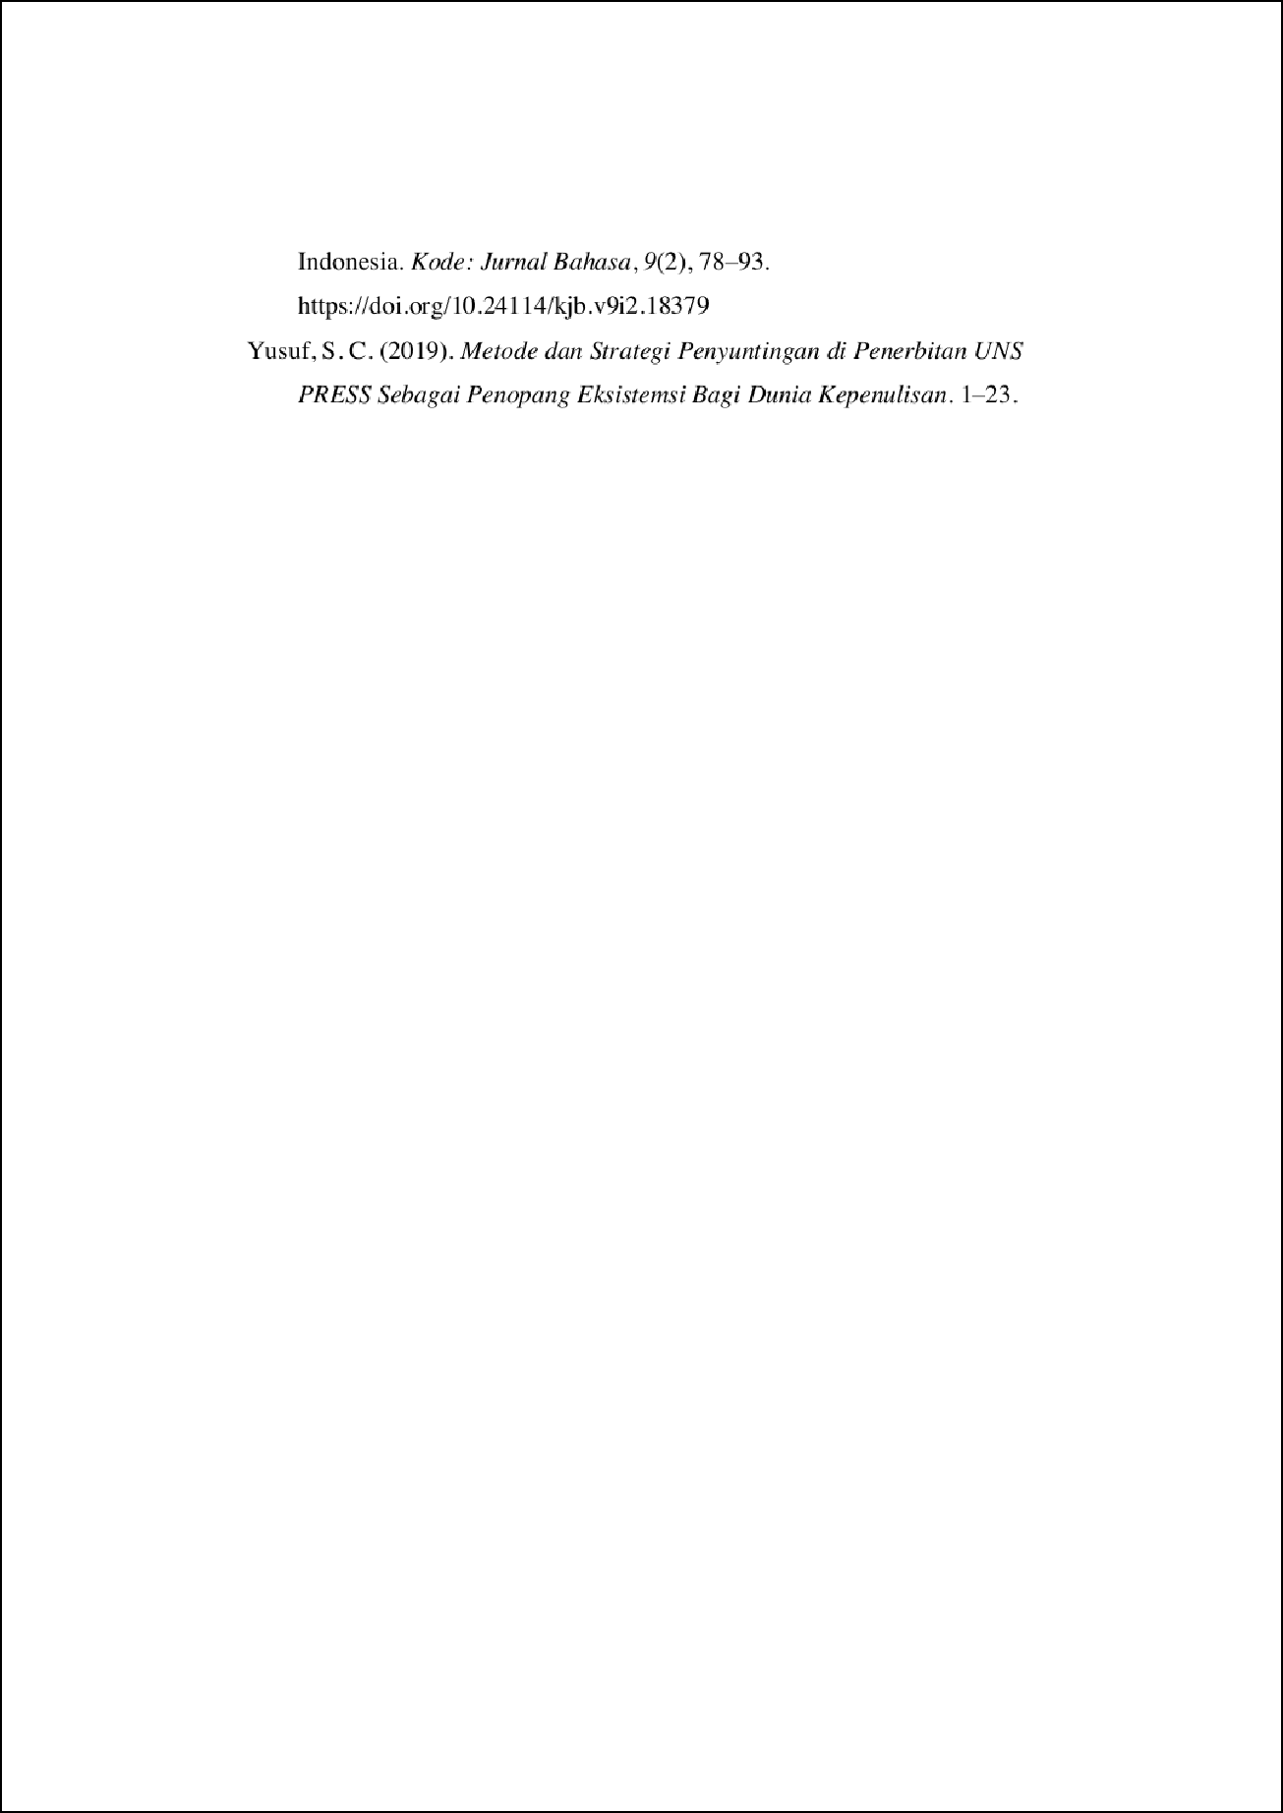

ARTIKEL LUARAN MAGANG PENYUNTINGAN Akbar Wika

Putra.pdf

21

ORIGINALITY REPORT

%

## SIMILARITY INDEX

15%

## INTERNET SOURCES

9%

## PUBLICATIONS

20%

## STUDENT PAPERS

PRIMARY SOURCES

# Submitted to Ajou University Graduate School

Student Paper %

1

8

6

# Submitted to Universitas Negeri Semarang

Student Paper %

2

2

# feb.uinjkt.ac.id

Internet Source %

3

2

# jurnal.stieganesha.ac.id

Internet Source %

4

2

# Submitted to Universitas Islam Riau

Student Paper %

5

1

# repo.poltekkes-medan.ac.id

Internet Source %

6

Exclude quotes Off Exclude bibliography On

Exclude matches Off