TITLE PAGE
Smoke-Free by Tradition: Indonesia’s Native Tribe’s Unique Way of Life
Nurul Kodriati^{1,2}, Lucy Popova¹
¹Faculty of Public Health, University of Ahmad Dahlan, Yogyakarta, Indonesia
²School of Public Health, Georgia State University, Atlanta, USA

Corresponding author:

Nurul Kodriati, Email: nkodriati@gsu.edu

ORCID ID:

Nurul Kodriati: https://orcid.org/0000-0003-2417-3590

Lucy Popova: https://orcid.org/0000-0002-3450-4579

Smoke-Free by Tradition: Indonesia’s native Tribe’s Unique Way of Life
Nurul Kodriati^{1,2}, Lucy Popova¹
¹Departement of Public Health, University of Ahmad Dahlan, Yogyakarta, Indonesia
²School of Public Health, Georgia State University, Atlanta, USA
Abstract
The Baduy are an indigenous Indonesian tribe that maintain a strict smoke-free lifestyle as part of their cultural and spiritual beliefs, in sharp contrast with Indonesia's high smoking rates and tobacco-oriented culture. Guided by the Pikukuh, a set of customary laws emphasizing purity and conservation, the Inner Baduy prohibit smoking entirely, while some Outer Baduy smoke minimally due to modern influences. This lifestyle provides a valuable public health example of how communal traditions can reduce smoking-related harm. By promoting a smoke-free environment, the Baduy provide a unique example for addressing Indonesia’s severe tobacco challenges and encourage healthier, sustainable living practices.
What this paper adds:
1. Alternative Health Model: Baduy’s smoke-free lifestyle can serve as a community-driven approach to public health, offering insights into culturally rooted approaches for reducing smoking in Indonesia.
2. Contrast to National Tobacco Culture: Baduy culture is a unique contrast to Indonesia’s high smoking rates and tobacco culture, challenging mainstream norms and offering an example of a sustainable, health-focused lifestyle.
3. Policy Inspiration: Baduy’s practices could inform policies for creating tobacco-free areas in Indigenous people’s areas.

The Baduy ethnic group, an indigenous community in Indonesia, is renowned for its dedication to traditional practices and ancestral values.¹ Located in Banten Province, about 120 kilometers from Jakarta, the Baduy people lead a strict, traditional lifestyle that contrasts sharply with contemporary life. The Baduy community is divided into two groups—Inner Baduy and Outer Baduy—and is believed to have descended from the Sundanese people, an ethnic group native to the western part of the island of Java, who withdrew into Banten's mountainous regions in the 16th century to preserve their beliefs from the growing influence of Islam. The Outer Baduy serve as a buffer to prevent visitors from entering the Inner Baduy’s sacred areas. This outer region contains more villages, where modern amenities, such as electronic devices, modern clothing, and small-scale trade, are more acceptable.² Figure 1 shows the houses in Outer Baduy.
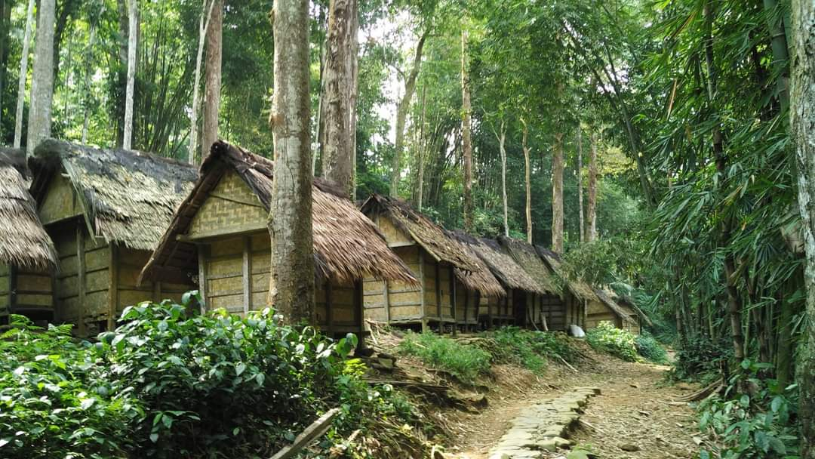
Figure 1. Houses in Outer Baduy (Photo by Any Sundari)
The Inner Baduy, residing in the villages of Cibeo, Cikertawana, and Cikeusik, adhere to a particularly strict set of taboos within the buyut system, keeping minimal contact with outsiders and prohibiting overnight stays for visitors. At the heart of Baduy culture is the Pikukuh, a set of customary laws and teachings that guide their lifestyle, relationships, and spirituality.³ The Pikukuh reflects a holistic approach to life that emphasizes ecological stewardship, sustainable farming, and harmonious social relations, echoing the global Sustainable Development Goals (SDGs) through their commitment to preserving forests and water resources for future generations.³ This guiding philosophy upholds that the human body is sacred and should be kept pure, forming the basis for the community’s strict prohibition against smoking.
For Inner Baduy, smoking is considered a polluting act that contradicts their commitment to purity and environmental respect. In contrast to other Indonesian traditions, such as the Ngukok smoking ritual among boys during Eid al-Fitr and Eid al-Adha in Jambi.⁴ The Inner Baduy strictly forbid smoking within their community. They also rigorously enforce a smoking ban, viewing it as harmful and disruptive to both human and environmental well-being. The inner area remains relatively free of tobacco advertisements. Meanwhile, some Outer Baduy may engage in smoking and cigarettes are available in small stores on the outskirts of Outer Baduy. For visitors and Outer Baduy alike, offering cigarettes or discarding cigarette butts within Inner Baduy territories is strictly prohibited, reinforcing the sanctity of their space and traditions.
This strict, smoke-free lifestyle is remarkable given Indonesia's high smoking rates and the prominence of tobacco in its culture. Indonesia has one of the world’s highest smoking rates, 33.8% of adults aged 15 and older use tobacco, with a striking gender difference: nearly two-thirds of men (62.9%) smoke compared to just 4.8% of women.⁵ Tobacco-related deaths were estimated at around 200,000 annually.⁶ ⁷ Despite efforts to implement smoke-free policies in 72% of districts and cities, enforcement is inconsistent, and smoking in public places remains pervasive.⁸ The cultural significance of kretek (clove cigarettes), which some advocate to be recognized as a national heritage, further complicates tobacco control efforts.⁹ A recent Netflix series “Gadis Kretek” or “Cigarettes Girl” revived this sentiment with the emphasis on the historical and traditional aspects of kretek.¹⁰ Traditional tobacco products are deeply ingrained in the nation’s customs, contributing to the normalization of smoking across generations.¹¹
In contrast to these broader cultural trends, the Baduy’s commitment to a smoke-free lifestyle presents a compelling alternative, highlighting the effectiveness of community-based approaches in maintaining a tobacco-free lifestyle. Nonetheless, the Baduy face challenges as modern influences increasingly encroach upon their community.¹² The influx of visitors and exposure to prohibited behaviors, such as smoking, risk influencing the younger generation, potentially weakening traditional values. As younger members interact more with modern lifestyles, preserving their cultural heritage becomes essential. In response, the Baduy are actively reinforcing their sustainable practices and prohibitions to retain their identity in the face of change.
Besides Baduy, Indonesia is home to an estimated 40 to 70 million Indigenous people,¹³ among a total population of approximately 270 million. Indigenous people collectively manage around 30.1 million hectares, though only 16% of this land has been formally recognized,¹⁴ mostly as part of protected forest and conservation areas. The Baduy community has received legal recognition within one of the 128 identified regulations protecting Indigenous Peoples' rights.¹⁵ Figure 2 shows the location where regulations for Indigenous People are in force.
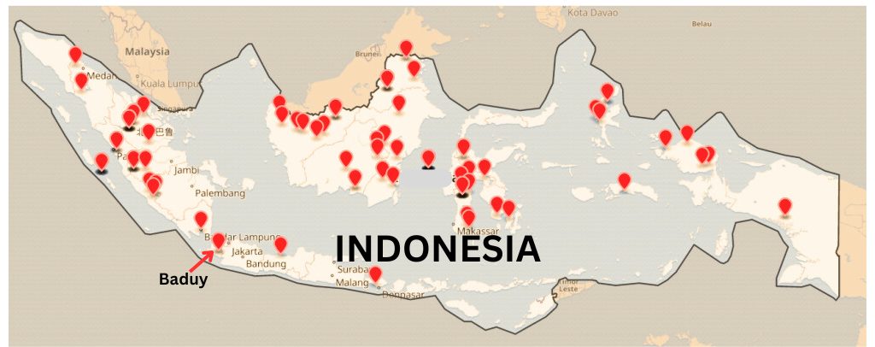
Figure 2. Map of the location where regulations of Indigenous People are in force. (Adapted from Wirjadisastra ¹⁵)
Following the 16th Conference of the Parties to the Convention on Biological Diversity (COP 16 CBD) in Cali, Colombia, in 2024, Indonesia is expected to establish a Subsidiary Body on Article 8(j) to protect traditional knowledge and practices related to biodiversity,¹⁴ ¹⁶ marking a significant step toward improving the implementation and enforcement of Indigenous rights, which are often overlooked or disregarded in practice.¹⁷ Even though COP 16 CBD focuses its work heavily on biodiversity, it shares a similar interest in respecting traditional cultures and knowledge. From a public health perspective, the traditional wisdom of the Baduy should be respected and preserved, as it aligns with sustainable living and offers a healthier model within a country grappling with tobacco-related health burdens. Establishing smoke-free areas in both Inner and Outer Baduy could be a way to safeguard their community from tobacco industry influences. Moreover, challenges from modernization are felt widely among Indonesia’s Indigenous communities. It remains uncertain how many Indigenous groups share Baduy's smoke-free philosophy, warranting further research to uncover other Indigenous wisdoms that may foster healthier cultural norms across Indonesia. Such knowledge can promote a renewed understanding among Indonesians, highlighting that the essence of their cultural heritage lies in environmental stewardship, harmony, and profound respect for the natural and healthy lifestyle.
Acknowledgement
We would like to express our sincere gratitude to Any Sundari and Dani Catrianiningsih for their invaluable contribution in providing first-hand information and insights as visitors and observers to the Baduy community. We are also deeply appreciative of the photographs they generously shared, which offer a unique and powerful visual perspective on this remarkable community.
Funding Statement
Funding provided by the Bloomberg Initiative to Reduce Tobacco Use through the CDC Foundation with a grant from Bloomberg Philanthropies.
The findings and conclusions in this report are those of the authors and do not necessarily represent the official position of the CDC Foundation.

References
1. As E, Aliyudin M, Nurdin FS, et al. Sunda Wiwitan: The Belief System of Baduy Indigenous Community, Banten, Indonesia. Wawasan: Jurnal Ilmiah Agama dan Sosial Budaya 2020;5(1):77-95. doi: https://doi.org/10.15575/jw.v5i1.8069
2. Mirajiani, Sulaeni, Sutisna T. The local farming system based on custom and tradition to achieve sustainable agriculture in Baduy indigenous community. IOP Conference Series: Earth and Environmental Science 2019;383(1):012032. doi: 10.1088/1755-1315/383/1/012032
3. Muntaha PZ, Runturambi AJS. The Local Wisdom of Baduy Reviewed From the Perspective of SDGs Concept: Research in the Indigenous People of Baduy, Lebak, Banten. Int J of Adv Res 2020;8:91-101. doi: https://dx.doi.org/10.21474/IJAR01/10602
4. Sasih A, Ananda A, Khaidir A. Ngukok tradition; A smoking habit in Kubang village2018.
5. Kementrian Kesehatan Republik Indonesia. Laporan Nasional Riset Kesehatan Dasar Indonesia 2018. Jakarta, 2018.
6. World Health Organization. WHO global report on trends in prevalence of tobacco use 2000-2025, third edition. 3rd ed. Geneva, 2019.
7. The Tobacco Atlas. Country factsheets: Indonesia 2019 [Available from: https://tobaccoatlas.org/factsheets/indonesia/ accessed July 5th 2024.
8. Martini S, Artanti KD, Hargono A, et al. Association between percentage of smokers and prevalence of smoking attributable morbidity in Indonesia: one decade after implementation of smoke-free area regulation. BMC Public Health 2022;22(1):2202. doi: 10.1186/s12889-022-14435-8
9. Astuti PAS, Freeman B. “It is merely a paper tiger.” Battle for increased tobacco advertising regulation in Indonesia: content analysis of news articles. BMJ Open 2017;7(9):e016975. doi: 10.1136/bmjopen-2017-016975
10. Andini K, Isfansyah I. Gadis Kretek (Cigarette Girl): Netflix, 2023.
11. Welker M. Kretek Capitalism: Making, Marketing, and Consuming Clove Cigarettes in Indonesia. Oakland, California: University of California Press 2024.
12. Leo P. Baduy people living between tradition and modernization. The Jakarta Post 2016.
13. Rinesti L. Indigenous people of Indonesia: Fight for their way: Climate Tracker Asia; 2022 [Available from: https://climatetracker.asia/indigenous-people-of-indonesia-fight-for-their-way/ accessed November 7 2024.
14. Aulia OD, Julianty C, Renggi ER. Masyarakat Sipil Indonesia Desak Pemerintah Dukung Agenda Masyarakat Adat di COP 16 CBD (Indonesian Civil Society Urges Government to Support Indigenous Peoples Agenda at COP 16 CBD). Cali, 2024.
15. Wirjadisastra. Wiki masyarakat adat: compiling data of Indonesian regulations about Indigenous people in Wikimedia projects Diff, a Wikimedia community blog; 2021 [Available from: https://diff.wikimedia.org/2021/02/01/wiki-masyarakat-adat-compiling-data-of-indonesian-regulations-about-indigenous-people-in-wikimedia-projects/ accessed November 6 2024.
16. Pangestu T, Gunawan A. Indonesia Dukung Pembentukan Badan Permanen Masyarakat Adat di COP16, AMAN : Ini Langkah Progresif (Indonesia Supports the Formation of a Permanent Body for Indigenous Peoples at COP16, AMAN: A Progressive Step) Jakarta: Aliansi Masyarakat Adat Nusantara; 2024 [Available from: https://aman.or.id/news/read/1952 accessed November 7 2024.
17. International Work Group for Indigenous Affairs. The indigenous world 2024. In: Mamo D, ed. 38 ed. Copenhagen: International Work Group for Indigenous Affairs (IWGIA), 2024:688.

