RESEARCH FINAL REPORT
Research summary between 250-500 words: research background, research objectives, stages of research methods, and targeted outputs. In this section, the researcher should describe the proposed research TKT.

SUMMARY
Digital health technologies are reshaping healthcare globally, with accelerated adoption in low and middle income countries (LMICs). The shift is particularly relevant in Southeast Asia where health disparities are influenced by socio-economic factors and geographic isolation. This study evaluates digital health solutions in Indonesia and the Philippines using the Digital Determinants of Health (DDoH) framework assessing impacts on health equity and outcomes. Indonesia’s TOMO (Tuberculosis Monitoring) app and the Philippines’ ATIPAN telehealth were evaluated. A diverse panel scored these solutions, followed by group discussions. The evaluations showed that digital health solutions like TOMO and ATIPAN, which are adapted to local contexts (needs) and existing practices, align well with the framework thereby advancing health equity. TOMO supports drug resistant tuberculosis patient management, while ATIPAN improves access to healthcare services for remote Indigenous communities. This study operationalized the DDoH framework to be used for evaluating digital health.
Keywords: maximum 5 keywords. Use semicolon punctuation (;) as a separator and written in alphabetical order.
digital determinants of health; digital health; health equity; tuberculosis; telehealth; health disparities
Results and Discussion (1000-1500 words) containing: (i) the recent progress of research and the achievement, (ii) the recent data obtained, (iii) the results of data analysis, (iv) result discussion, and (v) the recent outputs achieved. The data and research results can be presented in figures, tables, graphs, etc., that are supported by relevant and up-to-date references. All reported results or achievements must be related to the research phase planned in the proposal.
RESEARCH RESULTS AND DISCUSSIONS
Results
The overall DDoH rating of Indonesia’s TOMO was 3.2, averaged from individual (3.7), interpersonal (4.0), community (3.1) and societal (2.0) level scores. The Philippines’ ATIPAN scored 4.0 overall, from individual (4.4), interpersonal (4.2), community (4.7) and societal (3.2) average scores.
For TOMO raters, the ICC for average measures was 0.81 (95% confidence interval: 0.61-0.93; p<0.001). The scores given by A, W and D are strongly correlated (H’s scores were distant). The rater who when removed, most increased ICC (to 0.88) was H. Cronbach’s α was 0.83.
For ATIPAN raters, the ICC for average measures was 0.75 (95% confidence interval: 0.47-0.90; p<0.001). The scoring correlation was strong between J and L, but even stronger between A and G. The rater who when removed, most increased ICC (to 0.78) was L. Cronbach’s α was 0.75.
That Indonesia had the second highest TB prevalence rate in the world in 2020 (Chakaya et al., 2021) is among the reasons the country is turning to digital health to combat the disease. Tools like TOMO promote medication adherence in drug-resistant TB patients for their recovery and to prevent disease spread. The Philippines’ healthcare system suffers from maldistribution of health providers (Flores et al., 2021), most prominently in remote areas where Indigenous people reside. The ATIPAN telehealth program promotes digital health as a strategy to bridge isolated communities to the country’s healthcare system. How well these digital health solutions advance health equity was the evaluation this study explored using a recently-devised DDoH framework.
TOMO scored 3.1 overall by DDoH evaluation which is around the middle range in promoting health equity. In this study, the highest score of 5 is interpreted as having satisfied all requirements to bring about health equity, or improve it from the status quo. It follows that an equity-promoting solution counteracts health disparities. In comparison, ATIPAN scored 4.0 overall which can be considered strong in the promotion of health equity. Interestingly, ICC for the ratings of TOMO was 0.81, which is higher than ATIPAN’s at 0.75. This means that the Indonesian raters are in slightly better agreement about TOMO than the Filipinos are about ATIPAN. ICC of 0.75 and above indicates good to excellent reliability. Cronbach’s α was 0.83 for the reliability of the scale for TOMO, and 0.75 for ATIPAN - both above 0.70 which is considered the acceptable score
To further understand the characteristics of the raters (for Indonesia: H, D, W, A | for the Philippines: J, A, G, L) and their qualifications in rating digital health interventions, we calculated inter-item scoring correlations. These revealed that, for Indonesia, the scores of A, W, and D are correlated, whereas H’s scores are less so. In the Philippines, A and G’s scores are correlated, as well as J and L’s; however, A and G’s scores show more agreement than those of J and L. We aimed to identify the rater whose scores differed significantly from the others: these are H for Indonesia and L for the Philippines. We report the effect, on ICC, of removing these raters.
In the group discussions that followed the scoring exercise, we identified that for Indonesia H, D and W are considered experts while A is a non-expert on TOMO. In the Philippines, J is an expert on ATIPAN, A and G are semi-experts, while L is a non-expert. The expert’s knowledge is on account of direct experience in the design, development and/or implementation of the specific digital health solution (TOMO or ATIPAN). Interestingly, H, D and W are considered the experts yet D and W’s scores are more in agreement with A’s (the non-expert) by inter-item scoring. Since H gave the lowest scores to TOMO (2.75 on average, below the TOMO overall score), we can characterize H’s scoring as strict. Meanwhile, for the Philippines, the scoring of expert J and nonexpert L are correlated, though not as strongly as A & G, the semi-experts. We thought that there may be something about L’s background that more closely aligns with J’s expertise, and true enough, L is the lead for a digital health project (on mental health). Thus, while L may not be an expert on ATIPAN, nevertheless L has general experience in digital health. This means that experience in any digital health can translate to expertise when applying the current DDoH framework to evaluate specific digital health interventions. Interestingly, J of the Philippines gave the highest average score (4.25 on average, which is above the ATIPAN overall score). This was generous, in contrast to H (of Indonesia).
Cronbach’s α statistics for both TOMO and ATIPAN were above 0.70 which means the ordinal scale developed is reliable in evaluating DDoH of the digital health interventions in the two country-specific contexts. All in all, analysis of the DDoH by a group of intra-country evaluators of differing backgrounds and experiences indicate that there is good scoring agreement, and there was demonstrated reliability of the devised scale. Furthermore, experience in any digital health serves to align the ratings between specific expertise and general expertise. The purpose of this exercise was to see whether or not the digital health interventions promote health equity using the criteria in the DDoH framework. As mentioned earlier TOMO was medially aligned while ATIPAN was more aligned by virtue of the overall average DDoH scores.
Upon closer inspection, TOMO’s highest score (4.0) is at the interpersonal level, while ATIPAN’s highest score (4.7) is at the community level within the DDoH framework. This highlights the differing targets of these two digital health solutions: TOMO focuses on improving the interaction between patients and providers (interpersonal) to enhance outcomes for a specific disease (TB), whereas ATIPAN concentrates on providing marginalized communities with access to healthcare services. This demonstrates that the framework can effectively distinguish the strengths of different digital health interventions. At the same time, both TOMO and ATIPAN are shown here to be targeting “upstream” level DDoH. This is significant in attaining health equity for disparity populations because targeting upstream DDoH de-emphasizes individual/personal factors. Regarding weaknesses, both TOMO and ATIPAN score the lowest at the societal level (2.0 and 3.2, respectively). This is understandable, as LMIC societies are still catching up to high-income countries (HICs) in prioritizing and establishing the policies, standards, governance, and regulation necessary for effective digital health implementation.
It is noteworthy that at the societal level, Algorithmic Bias generated significant discussion, revealing that in both TOMO and ATIPAN, machine learning and artificial intelligence (ML/AI) are either unaddressed or underdeveloped. However, two raters for ATIPAN (J and L) interpreted this DDoH as referring to existing biases in healthcare against certain population segments, which could be exacerbated by digital health interventions that do not address these biases. They contended that ATIPAN was designed specifically to address the existing bias against remotelylocated and ethnically-marginalized communities in accessing health services. In TOMO, the bias might be that some TB patient groups (specifically non-drug-resistant patients) were not targeted during the app’s development, though the app’s use could be extended to them. This DDoH, along with Data Standards at this level, highlights the rapid globalization and push for digitalization and AI in the current healthcare landscape, as well as the need for LMICs in Southeast Asia, such as Indonesia and the Philippines, to advance more swiftly in this regard. The good news is that this DDoH framework, along with the methodology, scoring tool, and exemplar statistical analyses we performed, can rate existing digital health solutions and guide the development of new ones. We imagine that this framework will also guide the respective country authorities to move forward with societal facilitators for digital health (policies and standards) because digital health in LMICs will keep scoring low under the societal DDoH unless those are vastly improved. The Philippines’ ATIPAN clearly lends good evidence that digital health that is targeted to underserved communities can yield good results. ATIPAN was deliberate in its intention to reduce bias in healthcare services access due to ethnicity and geographic remoteness. Telehealth, as the modality of healthcare delivery, partially leveled the long-standing health disadvantages suffered by the Ati people. In short, the digital health solution was instrumental in promoting health equity. Scores for the individual and interpersonal factors were still high despite imperfect conditions (device non-ownership, unreliable internet) for digital health. Unlike societal variables, there was some control over these factors in the implemented intervention see (Zamora et al., 2024). The TOMO app addresses health inequities in drug-resistant TB care by enhancing access to monitoring for patients in remote or underserved areas, improving medication adherence through direct supervision, and enabling healthcare providers to track and manage treatment more effectively. By empowering patients and optimizing resource use, TOMO helps in bridging the gaps in care, reduces disparities, and improves overall treatment outcomes.
We examined two digital health solutions (TOMO and ATIPAN) designed, developed and implemented in Indonesia and the Philippines for their alignment to DDoH using the framework developed by (Richardson et al., 2022). We operationalized the framework by developing a scale, guide questions, a scoring tool and exemplar statistical analyses for reliability. We found, via DDoH evaluation, that TOMO and ATIPAN already promote health equity, though not yet perfectly. The main impediments are societal factors.

Output status, containing the type, identity, and the achievement of each mandatory output and additional output as stated in the proposal. The researcher should attach the document indicating the current status of the output, such as publication, intellectual property (HKI), experiment results, etc., as stated in the proposal. Scientific papers, books, etc., should attach similarity test results with a maximum of 25%.
OUTPUT STATUS
The results of this study have been written in a manuscript and have been submitted to the journal Health Promotion International.
The researcher should describe the role of partners in the context of cooperation realization and partner contributions both in-kind and in-cash (for Applied Research and Development/ Penelitian Terapan dan Pengembangan). Supporting evidence/document of this cooperation realization and contribution based on the actual conditions should be attached.
PARTNER ROLE
York has been awarded a grant (Grant No. 109981-001) from the International Development Research Center (“Sponsor”) which is governed by the Agreement commencing on August 1st, 2022.
Research Implementation Obstacles contain difficulties or obstacles encountered during conducting research and achieving the promised outcomes
OBSTACLES DURING THE RESEARCH
-
The Next Plan contains the researcher planning to complete the research considering the current achievements. In case there is a target that has not been reached until the research is done, in this section, the researcher allows to explain their plan to complete their target

NEXT PLAN
Our next plan is to wait this article publish on Journal of Health Promotion International

The reference is organized and written based on a number system according to cited order in the text. Only references cited in the document should be listed—a minimum of 25 references.

REFERENCES
Chakaya, J., Khan, M., Ntoumi, F., Aklillu, E., Fatima, R., Mwaba, P., Kapata, N., Mfinanga, S., Hasnain, S. E., Katoto, P. D. M. C., Bulabula, A. N. H., Sam-Agudu, N. A., Nachega, J. B., Tiberi, S., McHugh, T. D., Abubakar, I., & Zumla, A. (2021). Global Tuberculosis Report 2020 – Reflections on the Global TB burden, treatment and prevention efforts. International Journal of Infectious Diseases, 113, S7–S12. https://doi.org/10.1016/j.ijid.2021.02.107
Flores, E. L. L., Manahan, E. M. R., Lacanilao, M. P. B., Ladaw, I. M. B. T., Mallillin, M. M. B., Mappatao, N. T. Q., Leonardia, J. A., & Pepito, V. C. F. (2021). Factors affecting retention in the Philippine National Rural Physician Deployment Program from 2012 to 2019: a mixed methods study. BMC Health Services Research, 21(1). https://doi.org/10.1186/s12913-021-07219-0
Richardson, S., Lawrence, K., Schoenthaler, A. M., & Mann, D. (2022). A framework for digital health equity. In npj Digital Medicine (Vol. 5, Issue 1). Nature Research. https://doi.org/10.1038/s41746-022-00663-0
Zamora, P. R. F. C., Celeste, J., Rivera, R. L., Petrola, J. P., Aguila, R. N., Ledesma, J., Ermoso, M. K., & de Castro, R. (2024). The ATIPAN project: a community-based digital health strategy toward UHC. Oxford Open Digital Health, 2. https://doi.org/10.1093/oodh/oqae011

APPENDICES:
- Proof of publication

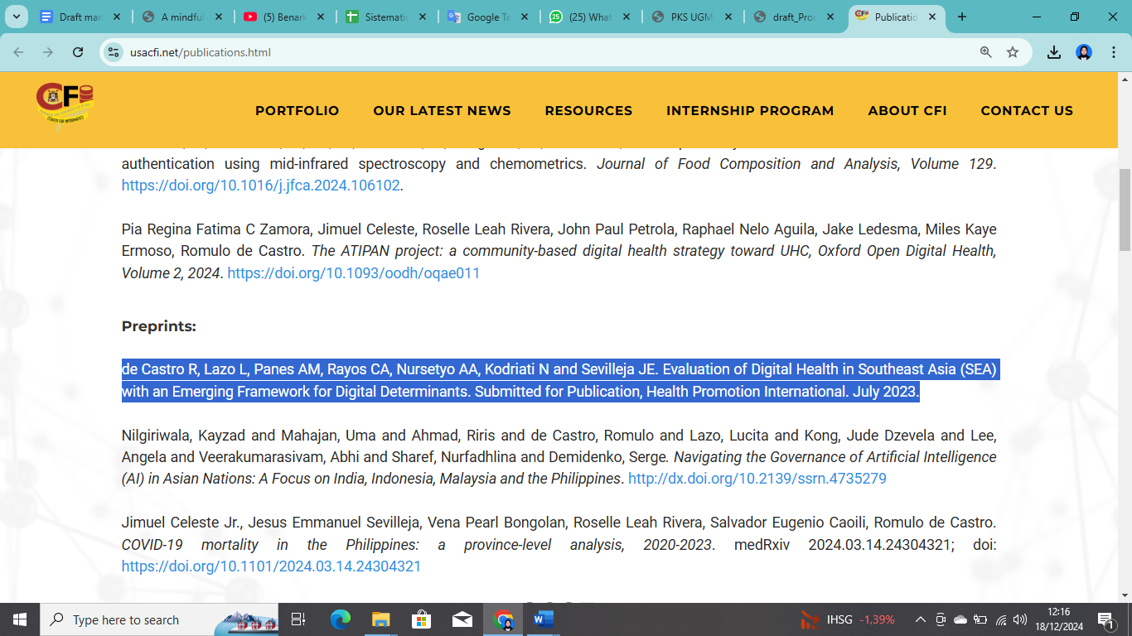

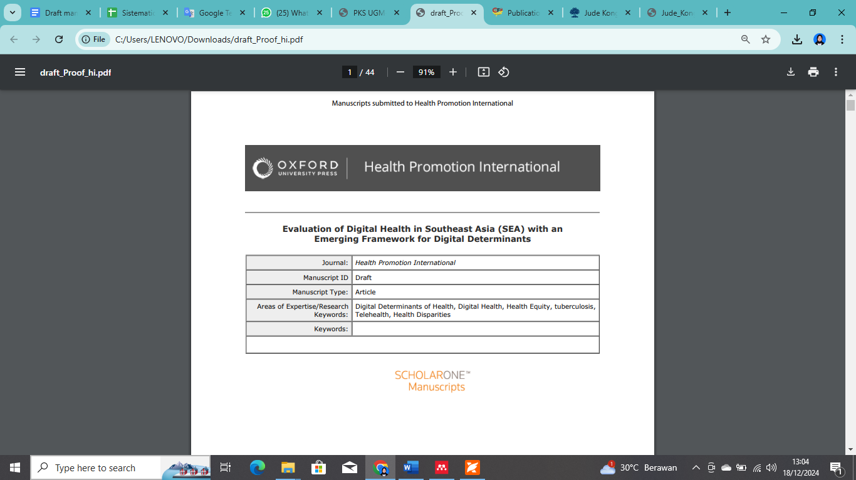
- Agreement of Research

